Arkaroola Wilderness Sanctuary

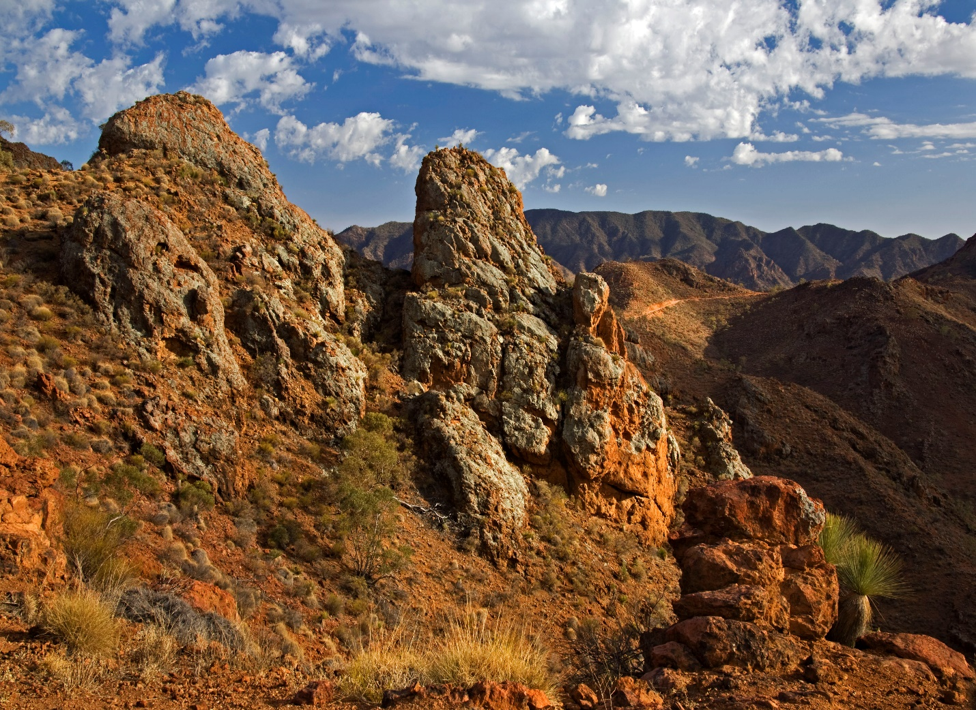

International Dark Sky Sanctuary Application
Version: 0.94
Issue Date: 10 February 2023
Document Status: Draft

DOCUMENT CONTROL SHEET
Release Notice
This is a managed document.
Changes will be issued as a complete replacement document covered by a Release Notice. All replaced documents should be destroyed immediately.
Revision History

Version | Issue Date | Author | Nature of Amendment
4.0 | Oct. 2019 | Dr. Peter Whellum | Document material collected together.
0.5 | Jan. 2020 | Padraic Koen | Proposed format as per business documentation.  Included Conformity section.
5.0 | Feb. 2020 | Dr. Peter Whellum | Some changes.
0.6 | Apr. 2020 | Padraic Koen | Moved most of v5.0 contents into v0.5 format.
0.71 | Apr. 2020 | Padraic Koen | Added to lighting inventory.
0.72 | Apr. 2020 | Padraic Koen | Added close-up and context photos to lighting inventory.
0.73 | Oct. 2020 | Padraic Koen | Added Aims of Arkaroola.  Added detail information about Astronomical Facilities and Activities
0.74 | Nov. 2020 | Padraic Koen | Moved Conformity details to an appendix.  Proposed contents for the Night-Sky Brightness Study Details
0.8 | Nov. 2020 | Padraic Koen | Included Arkaroola ‘Dark Skies Sanctuary’ Policy.  Added summaries of Conformity to IDSS Goals and Criteria.
0.81 | Dec. 2020 | Padraic Koen | Updates from internal review before sending out for external review.
0.82 | Dec. 2020 | Padraic Koen | Updates from review by A. Cool
0.90 | July 2021 | Padraic Koen | Updates from review by A. Dalton (IDA)
0.91 | Dec. 2021 | Padraic Koen | Completed Night-Sky Brightness Study Details
0.92 | Jan. 2022 | Padraic Koen | Rework Lighting Inventory
0.93 | Feb 2023 | Vicki-Lee Wilson | Rework Lighting Inventory
Security Classification

Security Area | Security Level | Description
Confidentiality | Commercial-in-Confidence | No harm could be caused to the organisation or any individual and no unfair advantage could be given to any entity and no violation would occur to somebody’s right to privacy.
Circulation Limit | Unrestricted | Unlimited access by any interested party
Acceptances

Role | Name & Title | Signature | Date
MANAGER:  (Endorsed) | Vicki Wilson
OWNER:  (Approved) | Douglas Sprigg

TABLE OF CONTENTS
1 Executive Summary 6
2 Introduction 8
2.1 Purpose of Document 8
2.2 Scope of Document 8
2.3 Point of Contact 8
3 Conformity to IDSS Goals and Criteria 10
4 Arkaroola Wilderness Sanctuary 12
4.1 Introduction 12
4.2 Aims of Arkaroola 13
4.3 Historical Overview 14
4.3.1 Geological History 14
4.3.2 Pre-European Settlement 16
4.3.3 Post-European Settlement 17
4.3.4 Recent Developments 18
4.4 Facilities 21
4.4.1 Accommodation 21
4.4.2 Utilities 21
4.4.3 Astronomical Facilities 22
4.5 Activities 26
4.5.1 Astronomical Activities 26
4.5.2 Education and Outreach 28
4.5.3 Tourism and Other Activities 29
5 Dark-Sky Management 30
5.1 Dark-Sky Management Policy 30
5.2 Lighting Inventory 32
5.3 Night-Sky Brightness Study 33
5.4 Lighting Management Plan 34
5.4.1 Lighting Management Plan Policy 34
5.4.2 Risks and Threats 35
5.4.3 Plans 35
5.4.4 Future Activities 36
6 Letter of Nomination 37
7 Letters of Support 38
7.1 Hon Steven Marshall MP, Premier of South Australia (2018-2022) 38
7.2 Hon Sussan Ley MP, Member for Farrer, Minister for the Environment (2019-2022) 39
7.3 Hon Dan van Holst Pellekaan MP, Member for Stuart, Minister for Energy & Mining (2010-2022) 40
7.4 Rowan Ramsey MP, Federal Member for Grey 41
7.5 Malcolm Walter PhD AM FAA FGSAust 42
7.6 Manual Lois MD, PCCP, FACP 43
7.7 Harald Ehmann, Arkaroola Wildlife Ecologist (Honorary) 44
7.8 Dr Eric Benson 48
7.9 Mark Wielgosz 48
7.10 Padraic Koen 49
8 Conformity to IDSS Goals and Criteria Details 50
8.1 Goals for International Dark Sky Sanctuary Creation 50
8.2 Eligibility Criteria 51
8.3 Minimum Requirements 52
8.4 Other Criteria 54
8.5 Lighting Management Plan Guidelines 56
9 Background of Arkaroola 58
9.1 The Legend of Arkaroo 58
9.2 Arkaroola – Mt. Painter Wilderness Sanctuary – A Brief History 60
10 Maps 62
10.1 Australia 62
10.2 South Australia 62
10.3 Arkaroola Pastoral and Freehold Lease Boundaries 63
10.4 Arkaroola Village 64
10.5 Night Sky Light Pollution Maps 65
10.6 Topographic Map 66
10.7 Proposed Flinders Ranges World Heritage Serial Property Map 67
11 Arkaroola ‘Dark Skies Sanctuary’ Company Policy 68
11.1 Objectives 68
11.2 Exterior Lighting 68
11.2.1 Pathways 68
11.2.2 Safety and Security Lighting – building exterior, veranda, etc 68
11.2.3 Street and Road Lighting 69
11.2.4 Illuminated Signs 69
11.2.5 Geographical or Geological and Natural Features 69
11.3 Interior Lighting 69
11.3.1 Motel Room Lighting 70
11.3.2 Workshops and similar type buildings and areas 70
11.3.3 Guest Activity Centres and Similar Areas 70
11.4 Office / Building ‘Security’ Type Lighting – Interior and Exterior 71
11.5 Staff and Company Motor Vehicles 71
11.6 Guests Use of Lighting and Nocturnal Activities 71
11.7 Implementation and Duration 71
12 Lighting Inventory Details 72
12.1 Lighting Inventory 72
12.2 Notes 74
12.3 Photos of Lighting 75
12.4 Planned Lighting Actions 76
12.5 Conclusions about Lighting Inventory 76
13 Night-Sky Brightness Study Details 77
13.1 Long-Term Night-Sky Brightness Monitoring 77
13.1.1 Tabular Summary of Long-Term Night-Sky Brightness Monitoring 77
13.1.2 Graphical Summary of Long-Term Night-Sky Brightness Monitoring 78
13.1.3 Graph of the Effect of the Moon on Night-Sky Brightness Readings 79
13.1.4 Representative Nights 80
13.1.5 Assessment of dark sky conditions via all sky calibrated camera 81
13.1.6 Conclusions from the Long-Term Night-Sky Brightness Monitoring 82
13.2 Location Photos 83
13.2.1 Ningana Imaging Observatory 83
13.2.2 Arkaroola Swimming Pool 84
13.2.3 Helicopter Landing Pad 85
13.3 Future Night-Sky Brightness Studies 85

Executive Summary
This document is an application from the Arkaroola Wilderness Sanctuary to the International Dark-Sky Association for International Dark Sky Sanctuary status to assist Arkaroola to promote the importance and value of dark sky places. It addresses all the goals and criteria in the International Dark Sky Sanctuary Program Guidelines, June 2018. Conformity to those goals and criteria is explicitly presented.
Arkaroola Wilderness Sanctuary and its not-for-profit entity, the Arkaroola Education and Research Foundation NGO, are committed to research, conservation, education and the promotion of all natural sciences.
The Sanctuary showcases almost 2 billion years of geological history, excellent dark skies for astronomical observations, unique wilderness, and is part of a proposed UNESCO World Heritage Listing.
The Arkaroola Protection Act 2012 provides for the proper management and care of the Arkaroola Protection Area (APA), and to prohibit mining activities. The APA meets international and national standards for what is considered a protected area and meets the definition of a “category II National Park” under the IUCN framework.

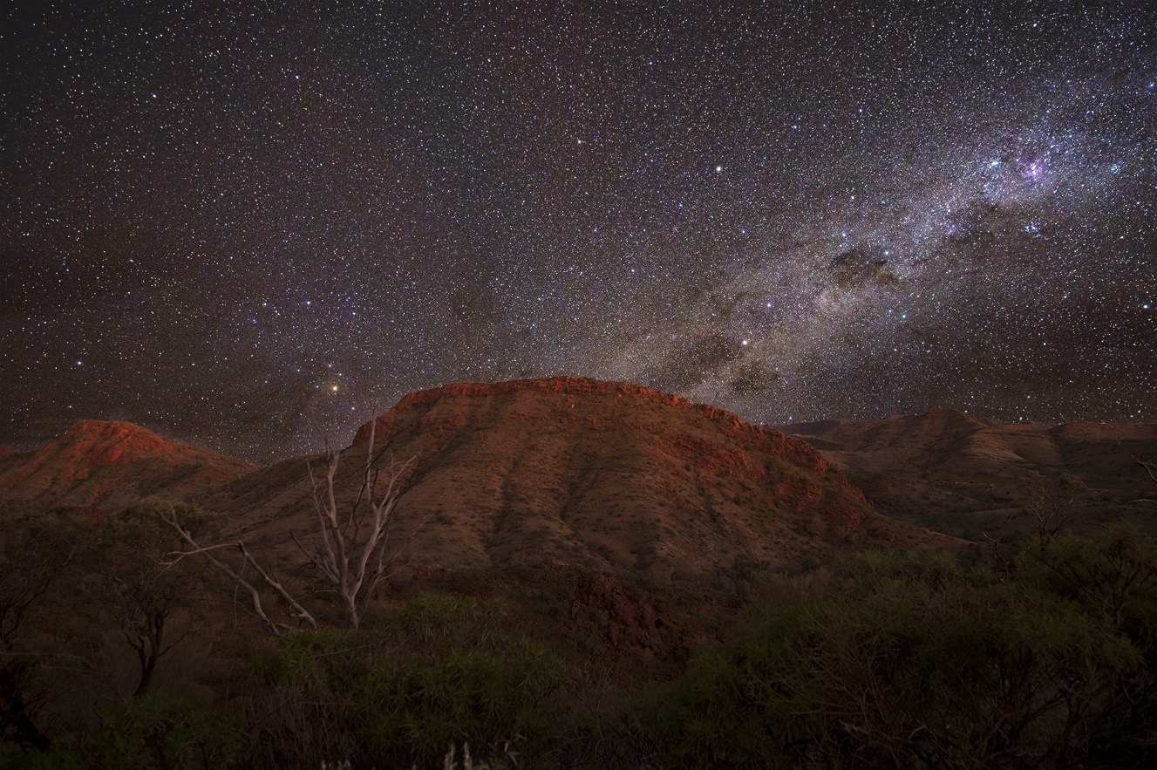
View from the Village looking south east
This application aims to achieve IDA accreditation as one of the darkest locations on Earth and for its exceptional commitment to and success in preserving the uniqueness of the rugged mountainous landscape, its flora, fauna, geology and night skies for all to enjoy. Arkaroola has some of the best astronomical seeing conditions in Australia and possibly the Southern Hemisphere. Data logged since September 2017 by a fixed continuous reading Unihedron Sky Quality Meter monitoring station reveals that:
- 52% of all readings between 9pm and 4am are greater than or equal to 21.5 magnitudes per square arc second, and
- 78% of all nights had at least one reading greater than or equal to 21.5 magnitudes per square arc second.
There are six separate observatories located near or within the Arkaroola Village, all of which are classified as Designated Optical Observatories (D03-51) with the Astronomical Society of Australia. Four of those observatories are used for research and Observatory Tours designed and operated to ensure an unforgettable “Stargazing” experience. Visitors to Arkaroola have access to these observatories and are encouraged to either bring their own telescopes or to join one of the Observatory Tours on offer. At least 1,500 visitors attend astronomy tours annually with an average of 280 clear nights per year.

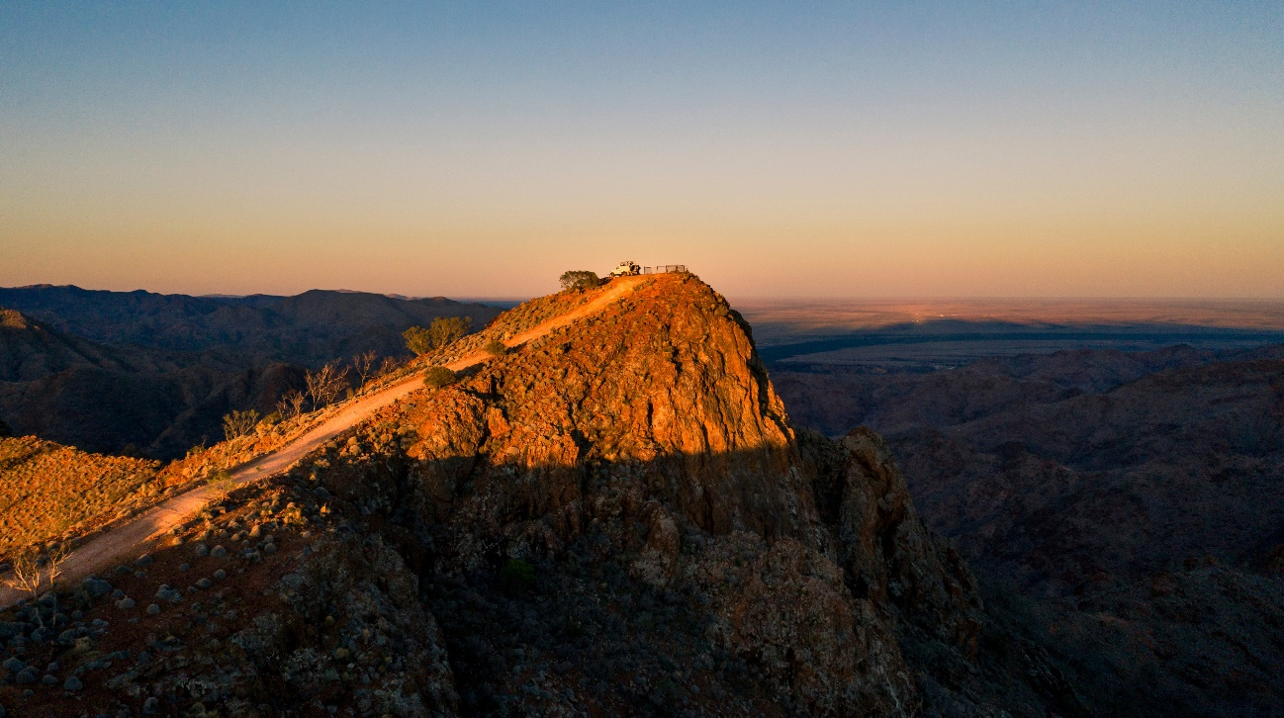

Siller’s Lookout on the Ridgetop with view east over the plains and Beverley Uranium Mine

Introduction

Purpose of Document
This document is an application from the Arkaroola Wilderness Sanctuary to the International Dark-Sky Association for International Dark Sky Sanctuary status to apply to the Arkaroola Pastoral and Freehold Lease Boundaries.

Scope of Document
This document addresses all the goals and criteria in the International Dark Sky Sanctuary Program Guidelines, June 2018, https://www.darksky.org/our- work/conservation/idsp/sanctuaries/. Conformity to those goals and criteria is presented in section 3, Conformity to IDSS Goals and Criteria.
This document does not present detail information about all aspects of Arkaroola, particularly those aspects not related to being an IDSS, such as the cost of tours and accommodations.

Point of Contact
The following is the person to contact in relation to this application.

Individual | Contact Details
Douglas Sprigg | Telephone: +61 (0)8 8648 4848  Email: doug.sprigg@arkaroola.com.au  Postal: Arkaroola Wilderness Sanctuary Private Mail Bag 106  Leigh Creek South Australia 5731  Australia
  - Intended Audience

Interested Party | Interest
International Dark-Sky Association | Approval of the application, specifically that the application addresses and meets all IDSS goals and criteria
Future applicants for IDSS status | Format and presentation of applications
General public | In dark sky places in general and as places to visit digitally or physically

  - Definitions and Acronyms

Term/Acronym | Definition
Arkaroola | Arkaroola Wilderness Sanctuary
Dicalum | Digital Camera Luminance, a library of functions that read in digital camera RAW images and convert them to standard arrays containing the luminance or radiance values of the pixels.
Fully Shielded | A light source that is screened, and its light directed in such a way that none is emitted above the horizontal plane passing through the lowest light-emitting portion of a fixture.
IDA | International Dark-Sky Association
IDSS | International Dark Sky Sanctuary. Sanctuaries are the most remote (and often darkest) places in the world whose conservation state is most fragile.
LMP | Lighting Management Plan
NSB | Night Sky Brightness measurement
MPSAS | Magnitude Per Square ArcSecond, a measure of brightness, or actually darkness
NGO | Non-Governmental Organisation, which is a non-profit group that functions independently of any government.
Pastoral Lease | An arrangement used in Australia whereby Crown land in remote parts of the State is leased from the government, more commonly for the purpose of grazing. See  <https://www.austrade.gov.au/land-tenure/Land-tenure/pastoral-leases>.  The Arkaroola Pastoral Lease No. 2240 is 610 square kilometres (61,000 hectares or approximately 151,000 acres).
Seeing | Seeing is the dispersal of photons due to variations in atmospheric density causing refraction, associated with turbulence.  Poor Seeing reduces object definition.
SQM | Sky Quality Meter, a tool for measuring luminance
Station | An Australian term used to describe pastoral properties of considerable size, generally measure in square kilometres.
Transparency | Transparency is the blocking of photons due to the density of particles in the atmosphere, notably by water vapour, and also smog/smoke/dust particles.  Poor Transparency makes objects more faint.

Conformity to IDSS Goals and Criteria
The following table provides a summary of Arkaroola’s conformity to the IDSS Goals and Criteria for acceptance as a Dark Sky Sanctuary. Appendix 8, Conformity to IDSS Goals and Criteria Details, addresses each goal and criteria point by point and links to the specific sections of this document that provides the detail information.

Goals and Criteria | Summary of Conformity
Goals for International Dark Sky Sanctuary Creation | This application aims to achieve IDA accreditation as one of the darkest locations on Earth and for its exceptional commitment to and success in preserving the uniqueness of the rugged mountainous landscape, its flora, fauna, geology and night skies for all to enjoy.
Eligibility Criteria | In 2012 the South Australian State Government enacted the Arkaroola Protection Act, part of which protects the Arkaroola pastoral lease from future mining activities. Arkaroola is the only wildlife sanctuary or national park in South Australia to be so protected against mining.  Arkaroola runs four fully equipped astronomical observatories, three located well above the village area and one conveniently located virtually at our reception area. Visitors have access to these observatories and are encouraged to either bring their own telescopes or to join one of the Observatory Tours on offer.  Data logged since September 2017 by a fixed continuous reading Unihedron Sky Quality Meter monitoring station reveals that:  - 52% of all readings between 9pm and 4am are greater than or equal to 21.5 magnitudes per square arc second, and  - 78% of all nights had at least one reading greater than or equal to 21.5 magnitudes per square arc second.
Minimum Requirements | The Arkaroola ‘Dark Skies Sanctuary’ Company Policy, appendix 11, first made in March 2005 and updated in 2021, provides guidelines to be followed by Arkaroola in the maintenance and upgrade of current lighting on the property.  Immediately prior to this submission, a full inventory of all outdoor lighting within the property was undertaken. 90% are deemed to be currently conforming to that policy, and the remaining 10% will be made conforming by the end of March 2024.  A permanent fixed Unihedron Sky Quality Meter monitoring station has been operational since September 2017.  Arkaroola are currently involved in discussions with senior management of the Beverley Uranium Mine, the only significant establishment within 100 kms., with a view to reducing their dark sky impact now and into the future. Subsequently, they have turned off all unnecessary lighting at well fields not in use, and are considering more appropriate lighting for their future developments. We are hopeful of even more successful outcomes.

Goals and Criteria | Summary of Conformity
Other Criteria | A formal point-of-contact is provided in 2.3.  Appendices include a letter of nomination (6), additional letters of support (7), maps (10), the Arkaroola ‘Dark Skies Sanctuary’ Company Policy (11), and a full lighting inventory and analysis (12).  Arkaroola Wilderness Sanctuary and our not-for-profit entity, the Arkaroola Education and Research Foundation NGO, are committed to research, conservation, education and the promotion of all natural sciences.  Arkaroola has received an Energy Grant and is included in a Proposed World Heritage Listing.  Should Arkaroola be awarded International Dark Sky Sanctuary status, it will include such identification on entrance signage to the property and other appropriate places.  Should any expansion be required, Arkaroola provides a commitment to the maintenance of its dark skies, its Lighting Management Plan and to ensuring that existing or improved lighting facilities minimise any impacts upon Arkaroola’s pristine dark sky environment.
Lighting Management Plan Guidelines | The overarching principles which have been and are to be applied to all outdoor lighting on Arkaroola includes:  - lighting is not to exceed the minimum number necessary to safely and adequately light a specific area,  - the use of low wattage lighting sufficient to provide staff and guest safety of movement at night, and  - complying with the Australian Lighting Standard 4282-1997 ‘Control of the obtrusive effects of outdoor lighting’ and with the ‘Safer by design’ guidelines prepared by the NSW Police.  Our Lighting Inventory shows that all operational lighting is deemed to be acceptable or appropriate for the purposes and times of use without interfering with our astronomy tours or other nocturnal tours and activities.

Arkaroola Wilderness Sanctuary

Introduction
The Arkaroola Wilderness Sanctuary (Arkaroola) is located in the rugged northern Flinders Ranges of South Australia with its motel area at 30° 18.7’ south, 139° 20.2’ east, at an elevation of 343 metres (1,125 feet). Arkaroola was established in 1968 as a privately owned flora and fauna reserve based around the diverse geology of the region by the late Dr Reginald Sprigg, a noted South Australian geologist and conservationist. Arkaroola is 700 kilometres (430 miles) north of Adelaide, the capital city of South Australia, and adjacent to the Vulkathunha-Gammon Ranges National Park, 30 km (19 miles) to the south. Arkaroola is in what is colloquially known as part of the remote ‘outback’ of South Australia. See Appendix 10, for map details.
Dr Sprigg had been educated at the University of Adelaide, South Australia, under the tutelage of the late Professor Sir Douglas Mawson, a famous South Australian geologist, Antarctic explorer and academic. Dr Mawson referred to Arkaroola as a great open air museum. It was during Dr Sprigg’s university days that he first visited Arkaroola with Mawson between 1937 and 1940. At that time Arkaroola was a struggling sheep station. Dr Sprigg was so impressed with the geology, flora and fauna of the area that he purchased the Arkaroola pastoral lease in 1968 with the aim of establishing a private wilderness sanctuary to protect the uniqueness of the area. Dr Sprigg’s objective was that a tourism business be established to foster appreciation for conservation and the sciences, and to financially support ongoing objectives of conservation, research and education in the earth sciences and astronomy.
The Arkaroola pastoral lease is 610 square kilometres (61,000 hectares or approximately 151,000 acres) and following its purchase by Dr Sprigg, permission was granted to remove the several thousand sheep on the property and to use the property for conservation and tourism purposes. Feral animals, primarily goats, donkeys, rabbits, cats and foxes seriously infested the original land. The Sprigg family have removed these feral animals, and with ongoing control efforts allowed the land to regenerate.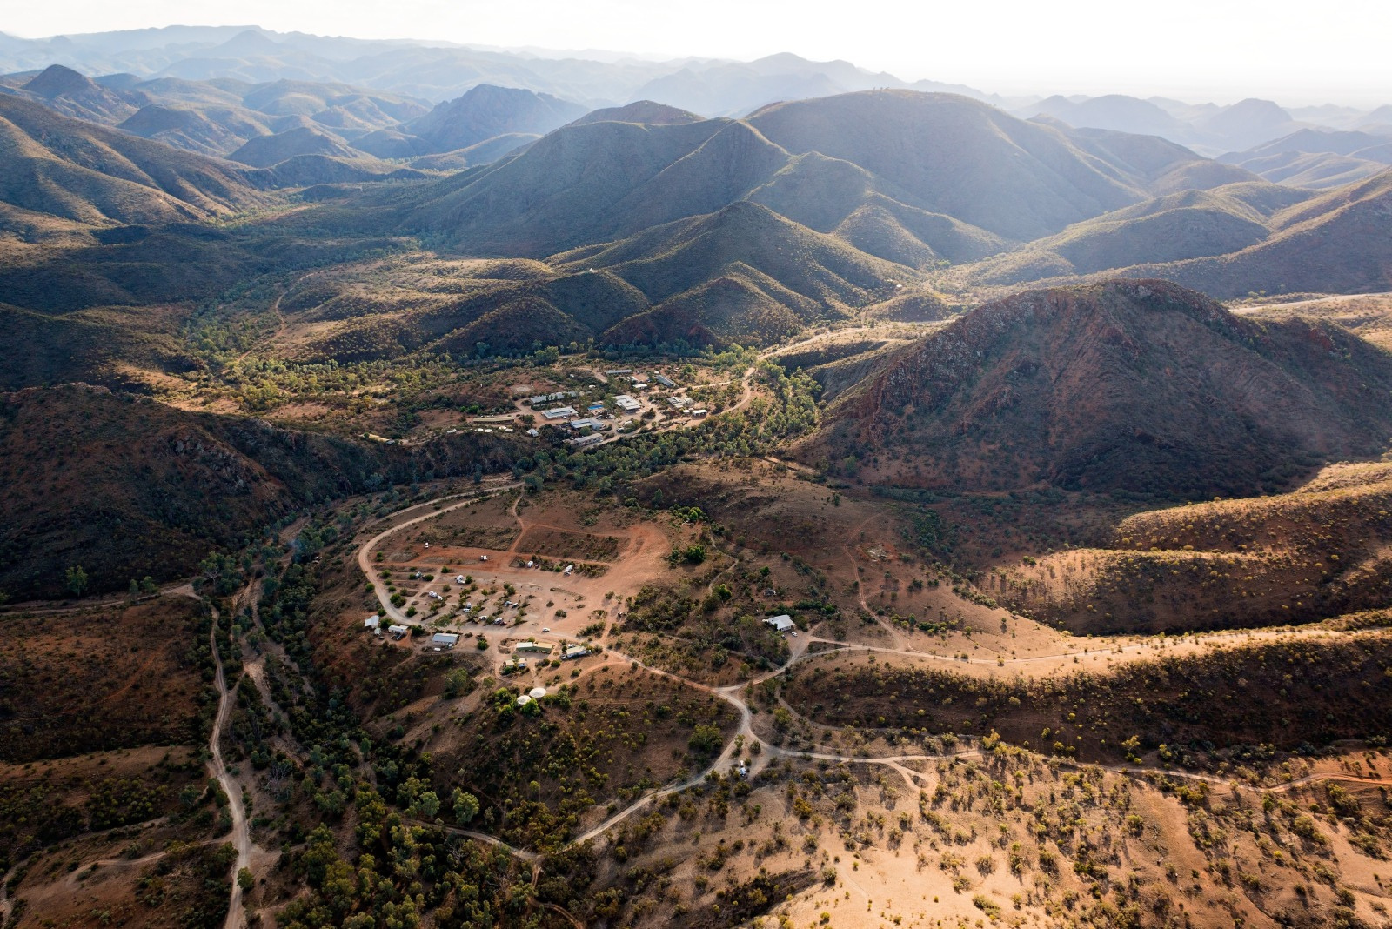
Arkaroola Village in the remote northern Flinders Ranges, South Australia

Aims of Arkaroola
Arkaroola Wilderness Sanctuary and its not-for-profit entity, the Arkaroola Education and Research Foundation NGO, are committed to research, conservation, education and the promotion of all natural sciences.
The long-term view of Arkaroola is that it is not owned by anyone in particular, because individuals are here on the planet for a very small snippet of time. Arkaroola intends to retain dark skies for the circadian rhythms of life as well as astronomy, and promote the land and sky for all.
While dry air and some elevation works well for visual astronomy, the remoteness of Arkaroola has slowed the uptake by high schools and tertiary education institutions using our facilities. Recent advances in internet, robotics and imaging techniques, however, are making Arkaroola more accessible. We are aiming to work more closely with secondary schools and universities and help to foster appreciation and interest in the sciences.

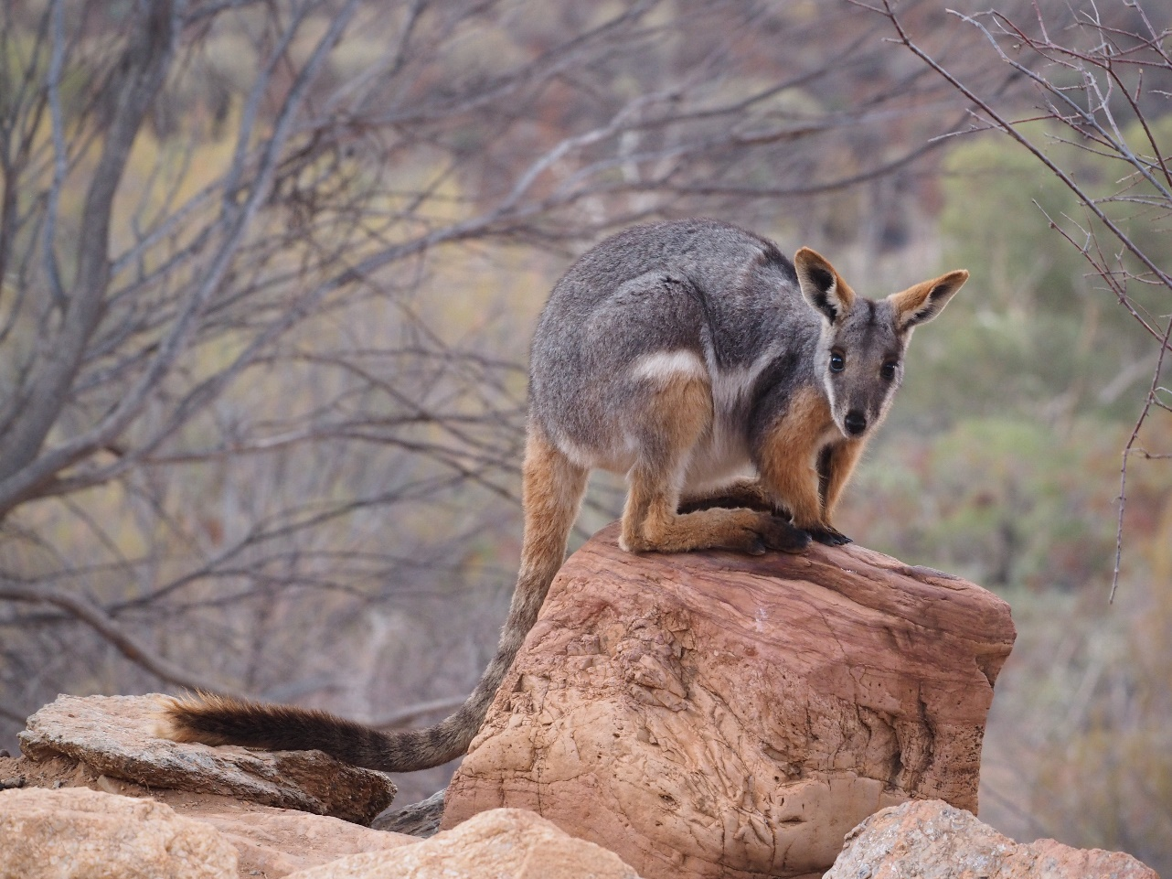

Ando / Yellow -footed Rock Wallaby (Petrogale Xanthopus), formerly under pressure are now abundant at Arkaroola. They are primarily nocturnal.

Historical Overview
A description of Arkaroola would not be complete without a description of the northern Flinders Ranges.

Geological History
Authored by Steve Hore, Senior Geologist, Geological Survey of South Australia and one of three lead authors of the World Heritage nomination for the Flinders Ranges
The Flinders Ranges is one of Australia’s magnificent landscapes, renowned world-wide for its wealth of natural, geological, culturally significant, historic and scenic values.
The rocks that form most of the Flinders Ranges were formed from sediments, primitive reef forming microbes and extruding volcanics depositing on a sea floor of a subsiding marine basin known, in geological terms, as the Adelaide Rift Complex. This evolving basin straddled Australia’s ancient continental margin and spanned a 350 million year time period from the Neoproterozoic (850 million years ago) to the Cambrian (500 million years ago).
Near the beginning of the Neoproterozoic, the breaking apart of an ancient supercontinent known as Rodinia commenced, including rifting along the line of the proto-Flinders Ranges which witnessed an outpouring of basaltic lava some 830 million years ago. The rifting helped develop the Adelaide Rift Complex and the volcanic activity is recorded by one of the earliest geological sequences of the complex.
In addition to these processes, Arkaroola has exposed today, the ~1600-million-year-old basal rocks on which they were deposited. Therefore, geological and geomorphological processes, some unique to Arkaroola, can be traced on the property from more than 1600 million years ago to present day. Combined, these rocks provide an exceptional depositional, tectonic and geothermal record of Earth history.
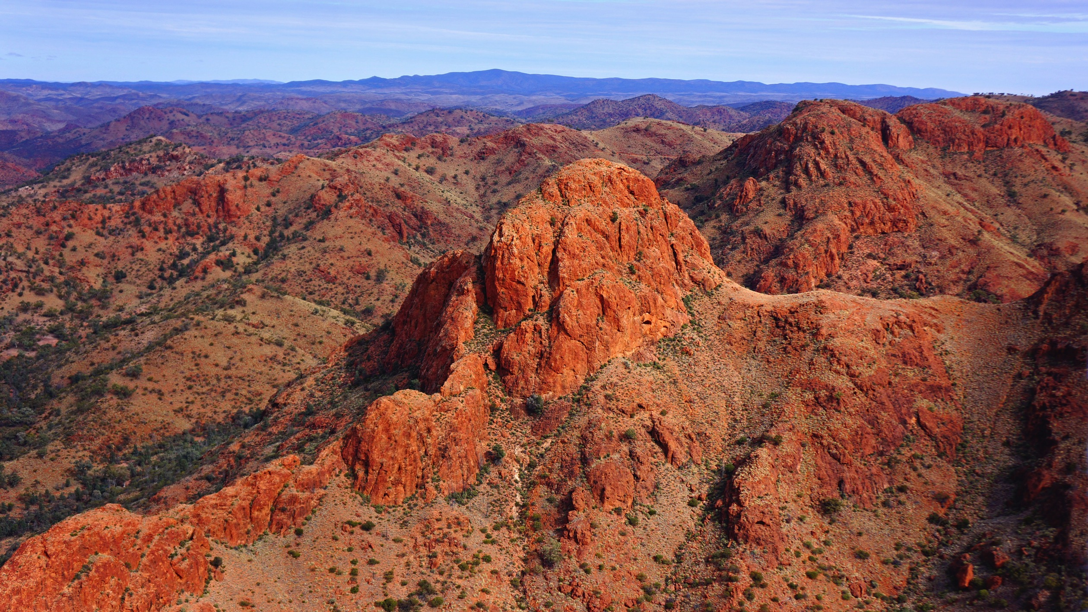
1600 million years rocks in the Ridgetop area of Arkaroola
The ~1600-million-year-old basal rocks are combination of sediments which formed in a basin much older than the Adelaide Rift Complex. These sediments were intruded by granites around 1590 million years ago and these are some of the most anomalously uranium-rich and radiogenic granites on Earth and contribute significantly to the basal package.
Plate tectonics moved early Australia to near the equator where it and other continents helped to cool the Earth by reflecting tropical heat rather than the oceans absorbing it. During the 350 million years of the basin’s depositional evolution, the sediments contributing to the Adelaide Rift Complex include glacial sediments of two distinctly independent phases of a Snowball Earth. At 717 million years, the Sturt glaciation, a 70 million year intensely cold period of immense glaciation, with ice extending from the north pole to the south pole, has been described by some as “Snowball Earth”. There was another massive climate swing 645 million years ago to the colder conditions of the Elatina glaciation, yet another episode, but much shorter period of “Snowball Earth”. It has been shown that at these times, when the whole Earth was covered in ice, the Arkaroola area and Australia in general was at the equator. Arkaroola and Australia’s positioning on the planet is due to plate tectonics.
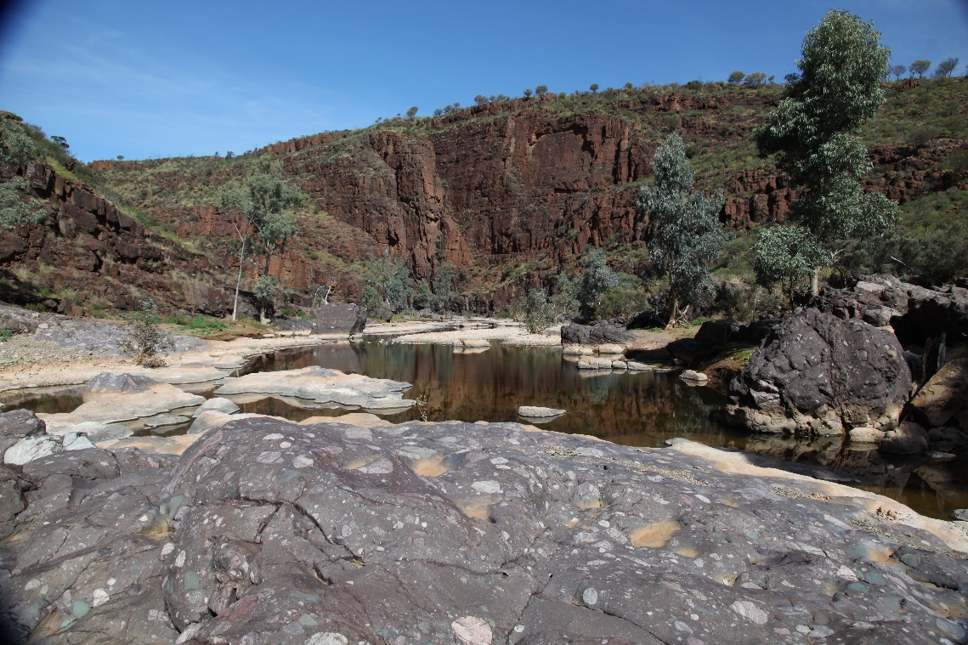
Tillite Gorge displays evidence of the first global ice age
The accumulation of the basin sediments in the Adelaide Rift Complex, up to 16 kilometres thick in places, contributed to their lithification into a stratified layered rock sequence. Cessation of a depositional regime in the subsiding basin was followed by the folding, uplift and erosion of these lithified rocks. This was a result of plate-tectonic related compression from the east at around 500 million years ago which is referred to as the Delamerian Orogeny.
Also, the 850 to 500 million year time period is the critical geological time-frame where the rocks capture the evolving planet and the evolution of life on Earth from single cell organisms to complex, macroscopic (multicellular) animal life and when they first emerged on Earth. Some of this critical evidence includes the world’s finest example of the Ediacaran explosion of life, when the earliest forms of complex multicellular animal life evolved.
Since the Delamerian Orogeny the geology of the Arkaroola region has continued to evolve geologically along with, and contributed to, the geomorphological aspects. Such as the formation of granites, hot springs and uranium remobilisation into minable pockets, these can all be attributed to the uraniferous granites. Besides heat generated rocks and mineral systems cold weather events continued after the “Snowball Earth”. Although there is negligible evidence of the Permian (~260 million years ago) glacial event in the Flinders Ranges, an Early Cretaceous (~130 million years ago) glaciation is evident on Arkaroola and immediate area, and this is the only known location on the planet with physical evidence of this event. The more recent glacial maximum, some 18, 000 years ago, had its imprint on the region. Although there was no ice nor snow in the Flinders Ranges the fall in temperature and introduction of severe climatic conditions, undoubtedly influenced the tolerance of human habitation and may have led to migration to more sheltered regions of the region. The formation of sand dunes to the north of the Flinders Ranges can be attributed to this cold event.
It is these outstanding geological and palaeontological forms within the Flinders Ranges, including Arkaroola, that make it an important site to pursue a Proposed World Heritage Listing.
Arkaroola presents the one of the most diverse geological areas of the Flinders Ranges, which is today still revealing it secrets to the geological community. Researchers and students are actively investigating, and communicating their science, to the wider global community. It is no wonder Arkaroola is the research hub of the Flinders Ranges.

Pre-European Settlement
Evidence of habitation in the northern Flinders Ranges dates back approximately 49,000 years. The original Australian Aboriginal people who occupied the northern Flinders Ranges were the Wailpi, Guyani, Jadliaura and Pilatapa, now collectively referred to as the Adnyamathanha.
According to Adnyamathanha dreaming or creation stories, a mythical snake named Arkaroo drank the nearby Lake Frome dry. As he crawled into the mountainous regions he urinated, creating various local waterholes, the Arkaroola Creek and forming the mountainous features we know today. See 9.1, The Legend of Arkaroo.
The small Aboriginal community of Nepabunna, 70 km (44 miles) by unsealed road south-west of Arkaroola, was established as a Christian Mission in 1931 ‘on land donated by Balcanoona Station owner Roy Thomas. It was the first permanent home the Adnyamathanha people had known since their displacement from their traditional lands in the early 1850s’. In 1997, after years of Mission and Government control, Nepabunna was handed back to the Adnyamathanha. In 2009, the Australian Federal Court recognised that the Adnyamathanha hold Native Title over much of the Ranges, including Arkaroola and its vicinity.
Arkaroola management work closely with local Adnyamathanha people to ensure culturally sensitive areas and features on the property are protected and respected by Arkaroola owners/management, employees and visitors. Employment opportunities are available to Adnyamathanha people and at the time of writing this submission two local Adnyamathanha people are employed in a variety of roles, including providing guided cultural tours from an Adnyamathanha perspective.

Post-European Settlement
Unlike other states of Australia, which were originally established as British penal colonies, South Australia was settled as a free colony in 1836. It has a total land area of 984,377 square kilometres (380,070 square miles). As early as 1840, the noted explorer Edward John Eyre passed by the northern Flinders to Mount Hopeless. A detailed survey of the northern areas of South Australia commenced in 1857 by G W Goyder and J M Painter and the first pastoral selection was by J Taylor and W T Gill. The Yudnamutana Copper Mining Field was discovered in 1860. Between 1863 and 1864, the ‘Great Drought’ saw many properties and mines abandoned; most pastoral leases in the northern Flinders reverted to Crown land. In 1910 the Yudnamutana copper smelters were constructed but never fired because of the harsh environment and logistical problems. Uranium was discovered at Mt Painter in the same year. Further uranium was discovered on Arkaroola in 1924. See 9.2, Arkaroola – Mt. Painter Wilderness Sanctuary – A Brief History.
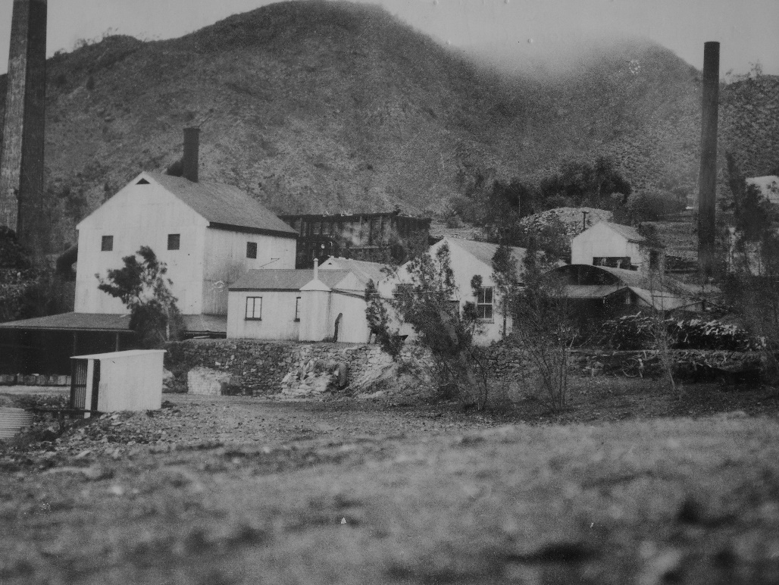
Yudnamutana Copper Smelter
The first pastoral lease over Arkaroola was granted to ‘Smiler’ and Bentley Greenwood in 1937 for the price of eradicating vermin. Although the Greenwoods reintroduced sheep, the Arkaroola Station struggled due to the rugged mountainous terrain and low average annual rainfall of 150 mm (6 inches).
Arkaroola’s neighbouring properties are Mount Freeling Station to the north and west, Moolawatana Station to the north east, Wooltana Station to the east, Umberatana Station to the west, and the Vulkathunha-Gammon Ranges National Park to the south (see map 10.3, Arkaroola Pastoral and Freehold Lease Boundaries).

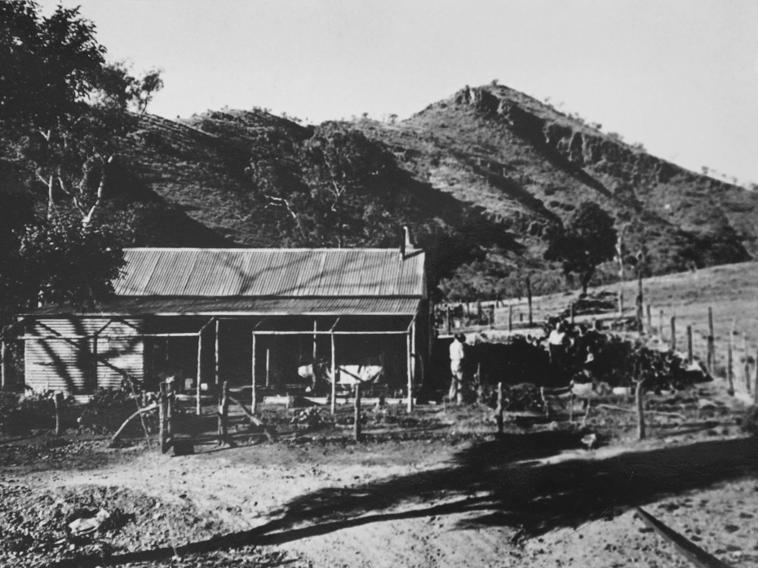
Arkaroola Station Homestead established 1937

Recent Developments
In the mid-1970s, freehold title was gained by the Sprigg family over 555.5 hectares (2.15 square miles) of land inside the southern boundary of the Arkaroola pastoral lease. This area includes the Arkaroola Tourist Village, Caravan Park and all observatories (see map 10.4, Arkaroola Village).
In about 2005, Arkaroola was successful in being the first Flinders Ranges tourism resort to achieve the coveted Advanced Eco-Tourism accreditation. Arkaroola’s third successive annual South Australian Tourism Award win in November 2007 for the category of Ecotourism saw Arkaroola awarded the coveted Hall of Fame and is undoubtedly one of South Australia's premier ecotourism destinations.
The Arkaroola land was reserved from the operation of the Mining Act 1971 and the Opal Mining Act 1995 by a proclamation of the Governor of South Australia. This was done on 29 July 2011 in the Government Gazette.
In 2012, following public outcry at attempts to mine uranium on Arkaroola, the State Government enacted the Arkaroola Protection Act, part of which protects the Arkaroola pastoral lease from future mining activities. Arkaroola is the only wildlife sanctuary or national park in South Australia to be so protected against mining. The Arkaroola Protection Area meets international and national standards for what is considered a protected area. Indeed, not only does it meet the International Union for Conservation of Nature (IUCN) definition of a protected area, but the Arkaroola Protection Area specifically meets the definition of a “category II National Park” under the IUCN framework. The Arkaroola Protection Act 2012 is therefore unique in establishing the Arkaroola Protection Area with the same legal status in South Australia as a National Park under the National Parks and Wildlife Act 1972.
The area entered in the State Heritage Register on 27 July 2012.

Energy Grant
Arkaroola is supported by local, State and Federal Government stakeholders that are keen to showcase the treasures of the region to the world and ensure the ongoing viability. A $1.3m grant has been awarded to design and carry out suitable technological trials at Arkaroola, with an educational component. The medium term goal is to use the learnings from the trial to build a renewable energy microgrid on site. This federal government grant for improving energy reliability in regional and remote communities will turn Arkaroola into a showcase for renewable energy technologies that:
        - suit remote harsh conditions,
        - can cope with the heat and dust,
        - operate reliably using only local skills and remote support, and
        - will provide insights and learning to other outback communities facing similar tensions.
For more information: https://business.gov.au/grants-and- programs/regional-and-remote-communities-reliability-fund- microgrids/grant-recipients-2020-21 .
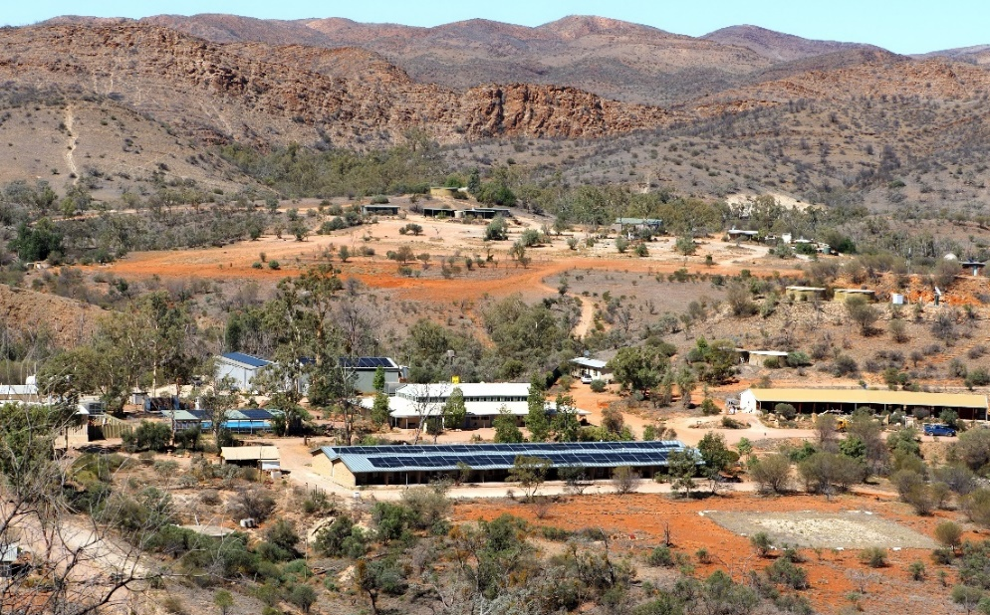
View from Oliphant Observatory over the Village showing the new panels for the 100MW solar system with 100MW battery storage

Proposed World Heritage Listing
In April 2021 UNESCO accepted a proposed Flinders Ranges World Heritage Serial Property to its World Heritage Tentative List. The estimated inscription on the World Heritage List by the World Heritage Committee is 2025.
The proposed Flinders Ranges World Heritage Serial Property, with its seven component parts, including Arkaroola (see the Proposed Flinders Ranges World Heritage Serial Property Map) presents an effectively unbroken record of the climate and environment conditions of Earth, and three evolutionary events that underpin the “dawn of animal life” on Earth. This major stage in Earth’s history extended over 350 million years from the Neoproterozoic Era to the Phanerozoic Eon at a time when animal life on Earth first evolved. It is the only place on Earth where such a near- continuous stratigraphic sequence and record of past climates and environment conditions interplaying with the emergence of animal life exists.
An analysis of all World Heritage properties, all properties listed on Tentative Lists and in the geological literature concludes that there is no equivalent single site that includes evidence of the emergence of animal life, spanning the Neoproterozoic and early Cambrian Period. The Flinders Ranges is one of a kind. No other site in the world can directly link the interaction between changing climates and environments on Earth with the evolution of animal life, for such a continuous period. For more information: https://www.environment.sa.gov.au/topics/flinders- ranges-world-heritage-nomination/ .
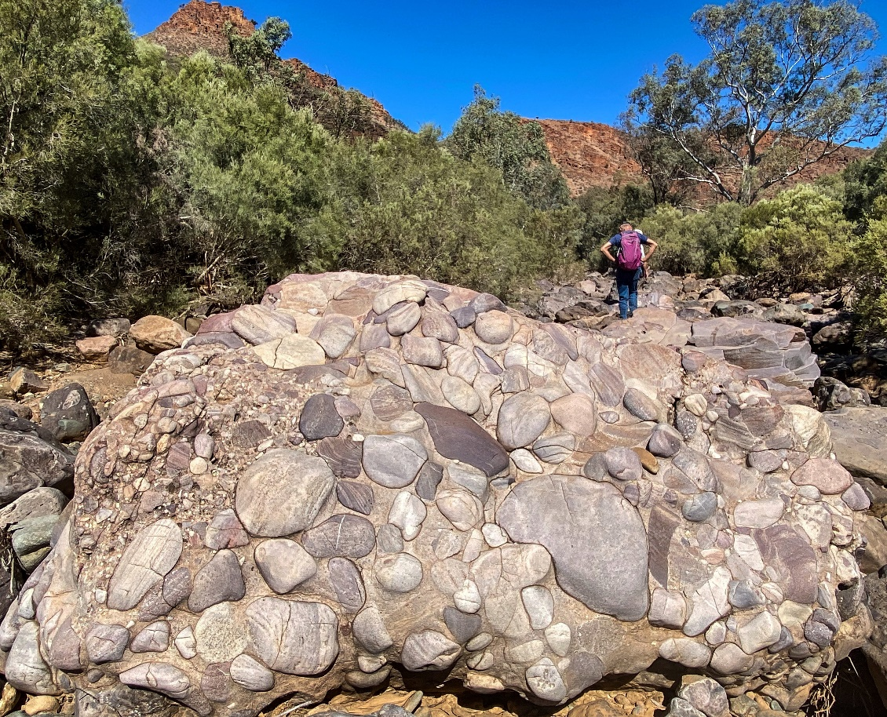
Drop-stone tillite in Tillite Gorge is one of the elements of the World Heritage bid

Facilities

Accommodation
Tourism is the only source of income for Arkaroola which is a multi-award- winning property, offering guests a range of accommodation (motel, self- contained cottages, caravan park with powered and unpowered sites, and bush camping facilities). There are three major motel-style blocks of accommodation, Mawson Lodge (20 motel rooms), Greenwood Lodge (19 motel rooms), and Callitris Lodge (10 motel rooms), 4 self-contained cottages, 4 basic cabins, and 2 bunkhouse type accommodation blocks within the caravan park. There are 50 powered caravan sites and 2 kilometres of bush camping along the Wywhyana Creek.
Human habitation is strictly limited to the 555.5-hectare Arkaroola Village area; overnight camping within other areas of the lease is discouraged and permission must be obtained from Arkaroola Management prior to such activity. The original Arkaroola homestead is located five kilometres to the east, at 30° 19.9’ south, 139° 22.2’ east at an elevation of 280 metres (918 feet). The homestead area contains accommodation and other facilities utilised by visiting schools and tertiary institutions; there is no permanent human occupation. The homestead is not visible from the main Arkaroola Village or any of its astronomical observatories.

Utilities
Energy and water consumption is low for a tourism environment. Reducing consumption is encouraged further by educating guests about the environmental challenges of running the village and providing incentives for guests to behave in low impact ways.

Electricity
Because of the remoteness of the location, and that the State electrical grid only extends as far as Nepabunna, 70 km (44 miles) to the west by road, Arkaroola is ‘off grid’, generating their own electricity from highly efficient and quiet CAT diesel generating systems. Where applicable, solar and battery technology is used in areas not serviced by Arkaroola’s private electrical grid. These generating systems have had little or no impact on the environment, including native flora and fauna. While it would be possible to connect to the State grid at Nepabunna, the existing infrastructure is only sufficient to supply the residents of that small Aboriginal community. If extended to Arkaroola, the whole grid from Leigh Creek (130 km to the west) would need to be upgraded to allow for the additional power load of Arkaroola, a multi-million-dollar exercise, the cost of which would be prohibitive. Fortunately, in 2021 Arkaroola was awarded an Energy Grant for $1.3m to design and carry out technological trials with a view to building a renewable energy microgrid on site.

Water
Water is a precious resource and is supplied to the Village from underground aquifers and the collection of rainfall, which amounts to only 254 mm (10 inches) per year on average. Appropriate notices are located in each bathroom, advising guests to be careful with their water consumption.

Communications
Telephonic and Internet services are provided to the village by both a digitised microwave link and satellite systems. Basic WIFI and Internet connectivity is available to visitors and staff. Telstra 4G mobile network is available across the entire village area with reception extending in some directions up to 5 kms further away. Beyond that, UHF (CB radio) is the only means of communication.

Astronomical Facilities
There are six separate observatories located near or within the Arkaroola Village, all of which are classified as Designated Observatories with the Astronomical Society of Australia. Four observatories are owned by the Sprigg family (owners of Arkaroola) and used for research and Observatory Tours offered to visitors.
Visitors to Arkaroola have access to these observatories and are encouraged to either bring their own telescopes or to join one of the Observatory Tours on offer.
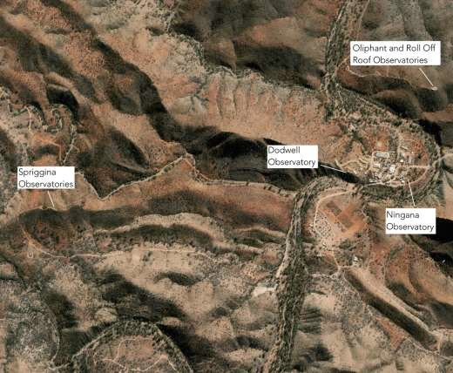
Aerial view of astronomical observatories’ locations in the Village area

Dodwell Observatory
Constructed in 1986 and located approximately 500 metres (approximately 550 yards) west of the main Arkaroola Village complex at 30° 18.7’ south, 139° 20’ east at an elevation of 363 metres (1,190 feet) above means sea level. Dodwell is a stone building with a 3 metre (10 feet) diameter dome containing a computer-aided Celestron C14 (14-inch f/11 Schmidt Cassegrain) telescope. A time-lapse photograph of the Dodwell Observatory is reproduced on the front cover of this application.
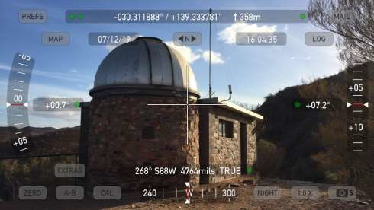

Oliphant Observatories
This observatory consists of two separate observatories located 500 metres (approximately 550 yards) north of the Arkaroola Village at 30° 18.5’ south, 139° 20.2’ east at an elevation of 396 metres (1,299 feet). The site is powered by its own solar/battery system. The two observatories contain of the following:
        - A 3.5 metre (11.5 feet), white fibreglass dome observatory containing a computer-aided Celestron C14 (14-inch f/11 Schmidt Cassegrain) telescope.
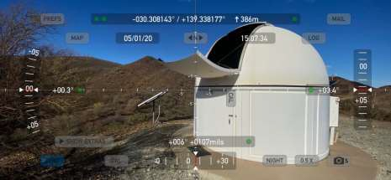

        - A roll-off roof building adjacent to the dome observatory, containing a 16-inch Go-to Dobsonian telescope, two Dobsonian 12-inch telescopes, and three Star Chairs fitted with 20 x 80 binoculars. Spare piers and wedges are also available for guests who bring their own telescopes.
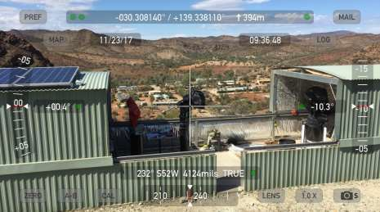

Ningana Imaging Observatory
Located within the Arkaroola Village area at 30° 18.7’ south, 139° 20.2’ east, at an elevation of 340 metres (1,115 feet). The observatory is located immediately east of, and adjacent to, the Ningana Interpretive Centre that provides light shielding from the main Village area. It is planned to have this observatory connected to the Internet at times when not being used for observatory tours.
Consisting of a 3 metre (10 feet) automated dome type observatory, the Ningana Observatory contains two telescopes:
        - a Celestron C14 (14-inch Schmidt Cassegrain telescope) operating with a f/2 Starizona Hyperstar lens and a ZWO ASI6200mc Pro Cooled astronomical colour video camera for fast, wide-field imaging, and
        - a Celestron C14 (14-inch Schmidt Cassegrain telescope) operating at prime focus, f/11, with a ZWO ASI183mc Pro Cooled astronomical colour video camera for imaging the planets and Moon.
These telescopes are mounted side-by-side on a Paramount ME, German Equatorial Mount (GEM) and utilise TheSkyX Pro software to drive the mount, and SharpCap software to operate the camera to give live views.

This observatory provides quality and fast deep space images for visitors, particularly ideal for those with visual impairments such as cataract and/or macular degeneration, or without the ability or desire to stand in a darkened observatory with a group taking turns at the eyepiece of a telescope. Live images from the observatory are displayed from either telescope to multiple large LED screens within the Ningana Interpretive building.

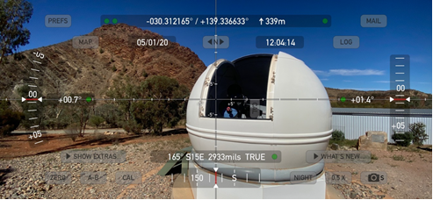

Spriggina Autonomous Observatories
Two privately-owned and operated dome observatories are located two kilometres (1.2 miles) west of the Arkaroola Village at 30° 18.7’ south, 139° 19.1’ east, at an elevation of 425 metres (1,394 feet). They are not visible from the Arkaroola Village. Both domes are 3 metre (10 feet) in diameter and communications, control and data retrieval are via a high speed satellite internet connection. Astronomical equipment consists of the following:
        - 20-inch Plane Wave Ritchey-Chrétien Cassegrain on a Paramount GEM, with monochrome CCD and colour wheel. Communication, control and data retrieval is via high speed internet.
        - Celestron C14 on a Paramount GEM. This observatory is now being subleased to a USA based organisation to find and track space debris that may be a danger to earth orbiting satellites and their launch vehicles.

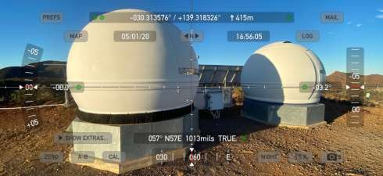

Activities

Astronomical Activities
In the far-northern Flinders Ranges, we are very fortunate indeed to have a world class atmospheric transparency index and sharpness due to our arid environment and elevation. Our skies are exceptionally dark due to our distance from any towns with Arkaroola employing a “low light” policy in the evenings.
We run four fully equipped astronomical observatories, three located well above the village area and one conveniently located very close to our reception area. All of our observatories are designed and operated to ensure an unforgettable “Stargazing” experience.
In addition to conducting Advanced Ecotourism Accredited Astronomy Tours, each of our observatories are available to professional and amateur astronomers, and to visiting astronomical societies and clubs.
The quiet months over summer have the greatest number of overseas visitors. Northern hemisphere guests are generally more aware of Australian outback, dark skies, appreciating them more than our locals. At least 1,500 visitors attend astronomy tours annually with an average of 280 clear nights per year.

Dodwell Observatory
This dome type observatory is primarily for direct eye to eyepiece tours conducted for guests and students. Very dark skies and typically good seeing allow us to showcase the best of southern night sky over two to three weeks per month. Typically tour duration is 1 ½ to 2 hours per session.
Capacity: 10 persons.

Oliphant
This dome type observatory is primarily for direct eye to eyepiece tours conducted for guests and students. Very dark skies and typically good seeing allow us to showcase the best of southern night sky over two to three weeks per month. Typically tour duration is 1 ½ to 2 hours per session.
Oliphant is also operated during daylight hours for direct viewing of sunspots in normal visible light and solar prominences and granularity in hydrogen alpha.
Capacity: 15 persons.

Roll-Off Roof
This observatory is primarily used by visiting astronomers at night and situated adjacent to the Oliphant observatory. Access to this observatory is normally free of charge as long as we are confident patrons know enough to look after the equipment. This observatory is also used to develop and test computer control interface systems along with image gathering tests.
Capacity: 10 persons.

Ningana Imaging Observatory
The Ningana Observatory is a robotic facility primarily for tours conducted for guests and students. It was initially developed to allow guests with night vision impairment to see deep space objects, but has found much wider acceptance. It is particularly popular around full moon window when direct viewing is not at its best. The telescopes yield high quality colour, deep space images in near real time. Images develop and display on big screen TVs (post processing software is also available but usually not used during tours). This facility is situated in the Arkaroola motel area so visitors with mobility issues may maintain a connection with the telescope providing the images. Placement of this observatory dictates we keep light pollution in the village to a minimum in keeping with IDA aspirations. This observatory has the ability to be accessed remotely via internet at times when not being used for tours.
Capacity: 50 persons.
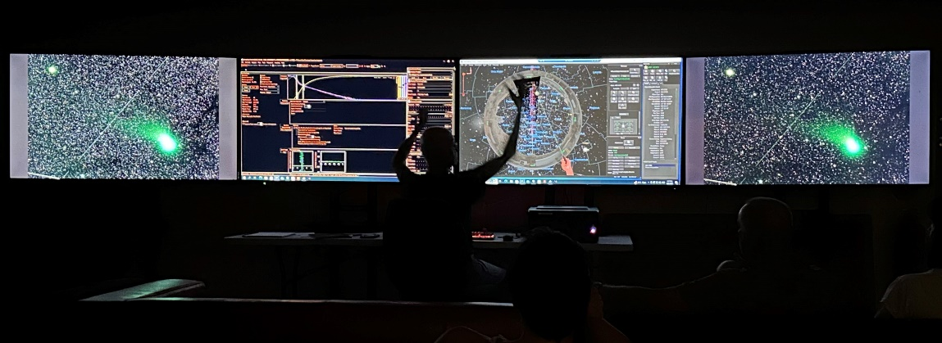

Live viewing of the C/2022 E3 (ZTF)﻿ (The Green Comet) 9 February 2023

Spriggina Autonomous Observatories
Two privately owned and operated robotic and autonomous dome observatories.
Capacity: 0 persons.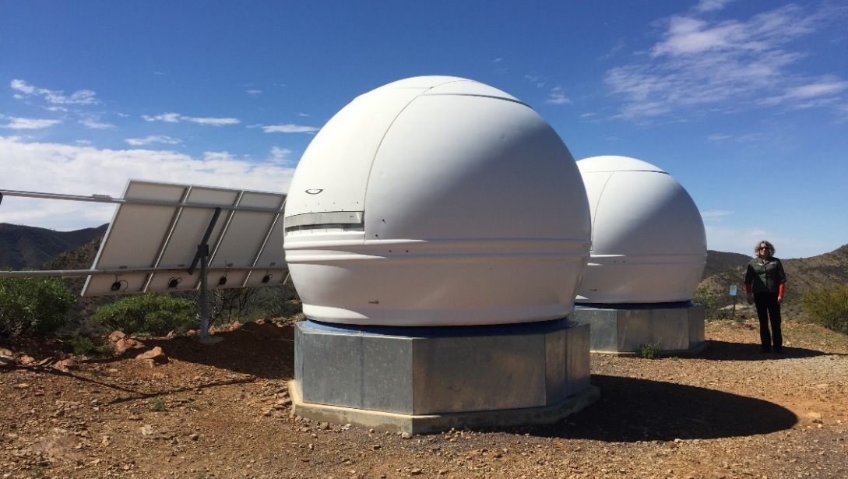

Education and Outreach
Education is a core value at Arkaroola. Around 15,000 visitors per year experience the natural environment and local history. Indeed, the Mt. Painter-Arkaroola region was recommended for protection as far back as the 1920s by the geologist and Antarctic pioneer Professor Sir Douglas Mawson. He considered the area of great natural importance and referred to it as “One great outdoor museum”.
The Arkaroola Education and Research Foundation was established in 2015 as a not-for-profit, non-government organisation. It encourages the pursuit of careers in the various scientific disciplines and groups of students use the site for geological and astronomical investigations. Its objective is the protection and management of the Arkaroola pastoral lease in perpetuity for:
- conservation, including the maintenance of its pristine dark night skies,
- education,
- research,
- fostering an interest in the natural sciences, and
- creating a path for young students to pursue careers in the various scientific disciplines.
The recent Energy Grant will add remote energy technology and engineering to the list of educational experiences. Throughout the trial, the site will welcome visitors and students to learn about energy and water sustainability and experience the performance of the technologies being tested. At the end of the trial, a public knowledge sharing report will be produced.
The bid for the Proposed World Heritage Listing stated that inclusion will “celebrate the region’s outstanding geology and fossil values, and to share them with all present and future generations as part of the Flinders Ranges story that is rich with cultural, environmental and social values and connections”. This is supported by many activities at Arkaroola.
Arkaroola has been an outdoor education site of choice for high school and university students from Germany, Holland, UK, USA and Australia. Research projects in botany, geology and palaeontology have been conducted at Arkaroola with university groups, including SA Geological Survey and Cambridge University, UK. Over the last 30 years, Arkaroola has supported these activities through affordable accommodation and study facilities. The Arkaroola Educational and Research Foundation primarily focuses on earth sciences, and working with the Mars Society of Australia, has been expanded to encompass Mars analogues, with the goal of the search for extra-terrestrial life.
We aim to attract more astrophysics students for research projects. We also hope to use more students and postgraduates as tour guides so they may have an income while studying, and to broaden their communication skills.
Arkaroola is now seeking International Dark Sky Sanctuary (IDSS) accreditation as we believe their association goals coincide with our conservation and science education objectives, while expanding the ability for on-site and remote access research projects.

Tourism and Other Activities
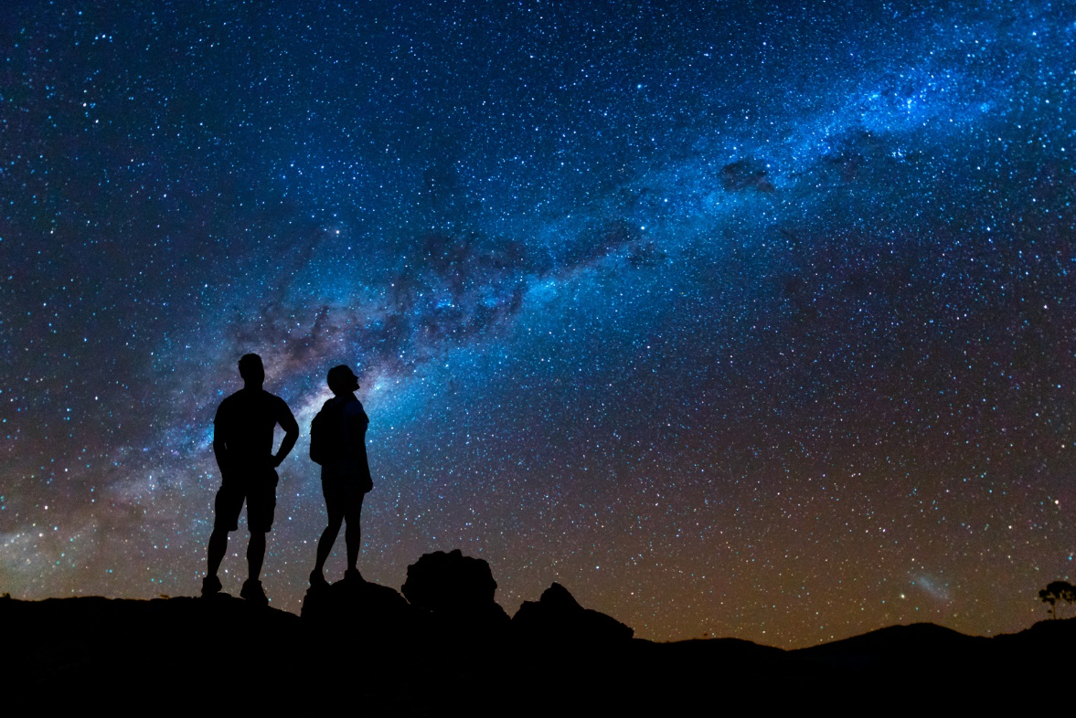
Visitors and astronomers enjoy the dark skies of Arkaroola
Arkaroola is an inspiring destination for artists, aviators, astronomers, adventure bikers, birdwatchers, bushwalkers, four-wheel drive adventurers, geologists and just about anybody with a sense of adventure and a quest for knowledge.
The Sanctuary showcases almost 2 billion years of geological history, excellent dark skies for astronomical observations, unique wilderness, and is part of a Proposed World Heritage Listing.
Tourist activities include 4WD tours, scenic flights, cultural tours, and bushwalking, as well as the astronomy tours described in section 4.5.1. These activities are presented in https://www.arkaroola.com.au/.
There is no admission fee to enter the property.
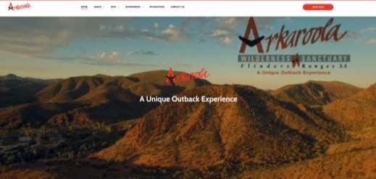
Arkaroola’s website

Dark-Sky Management

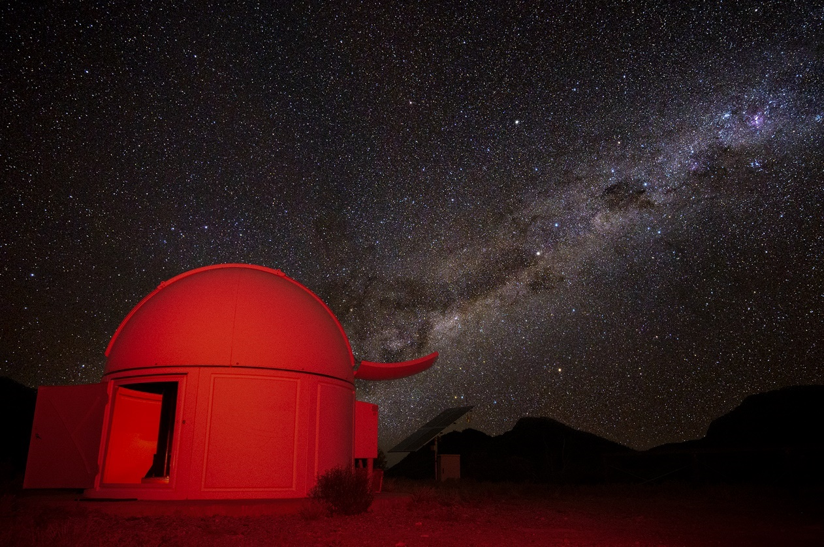
Oliphant Observatory

Dark-Sky Management Policy
Arkaroola’s commitment to astronomy and the maintenance of clear, unpolluted dark skies, is demonstrated by the following.
- The purchase of the Arkaroola pastoral lease in the first instance in 1968 with the aim of preserving the uniqueness of the rugged mountainous landscape, its flora, fauna, geology and night skies for all to enjoy.
- In May 1991, R. H. McNaught of the Siding Spring Observatory discovered a new asteroid and named it (5380) Sprigg, named after Dr Reg Sprigg in recognition for his services to the earth sciences.
- The erection, from 1986 to the present, of four Arkaroola owned observatories that are classified as Designated Observatories with the Astronomical Society of Australia.
- The hosting of various star parties.
- A ‘Dark Skies Sanctuary’ company policy (see appendix 11, Arkaroola ‘Dark Skies Sanctuary’ Company Policy) was adopted by Arkaroola management in 2005 and updated in 2021 in order to preserve the unpolluted darkness of Arkaroola’s night skies and has formed the basis of our Light Management Plan.
- The Arkaroola Welcome Pack explicitly requests visitors to “help reduce impacts on wildlife and aid the astronomy operations in the area by keeping bright lights to a minimum and avoid pointing them upwards.” It also invites visitors to “take the opportunity to enjoy our dark sky environment.”
- The application for IDA Dark Sky Sanctuary status.
- Local power generation results in a requirement to be frugal with the use of electricity, particularly outdoor lighting within the Village and elsewhere on the property. There is no street or road/track lighting within the Village. Arkaroola utilises as many modern, state-of-the-art power-saving devices as possible, and was awarded an Energy Grant to design and build a renewable energy microgrid on site to further reduce Arkaroola’s energy consumption.

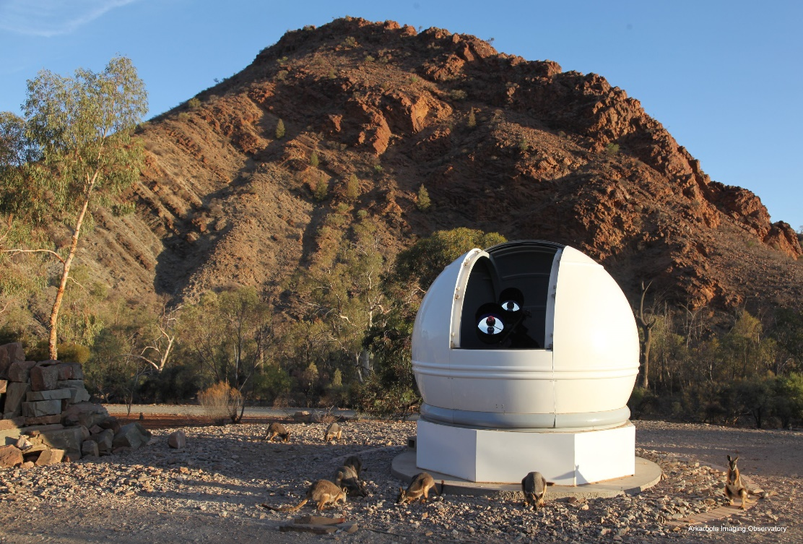
Ningana Observatory within the Village is used for real-time Astro imaging tours demonstrating the darkness of the sky within the Village

Lighting Inventory
Immediately prior to this submission, Arkaroola management undertook a full inventory of all outdoor lighting within the property (see appendix 12, Lighting Inventory Details).

The following is a summary of the conclusions from the lighting inventory.

Description | Qty | Percent
Lights in total currently | 154 | 100%
Lights currently non-operational, all to be replaced or removed | 3 | -
Lights currently too bright or too broad | 4 | 2.6%
Lights currently with partial or no shielding | 11 | 7.1%
Lights currently fully conforming | 139 | 90.3%
Lights that must be fully conforming before applying for IDA certification | 103 | 67%
Lights planned to be replaced | 15 | 9.7%
Lights planned to be removed | 3 | -

Night-Sky Brightness Study
The darkness of Arkaroola is detailed in Appendix 13, Night-Sky Brightness Study Details. Bortle Scale light transmission appears to be between 0 and 1, though this is tempered by the understanding that most objects measured or compared against are well in the northern hemisphere.
Data logged since September 2017 by a fixed continuous reading Unihedron Sky Quality Meter monitoring station (see Appendix 13.1, Long-Term Night-Sky Brightness Monitoring) reveals that:
- 52% of all readings between 9pm and 4am are greater than or equal to 21.5 magnitudes per square arc second, and
- 78% of all nights had at least one reading greater than or equal to 21.5 magnitudes per square arc second.
These data are significantly better than 21.5 magnitudes per arc second required for International Dark Sky Sanctuary accreditation.
Recent satellite data (https://www.lightpollutionmap.info) demonstrates that the entire uninhabited Arkaroola region is rated as having a nominal Zenith brightness of 22mpsas, excluding the Beverley Uranium mine to Arkaroola’s east.
Arkaroola will continue to use its permanent fixed Unihedron Sky Quality Meter continuous monitoring station at the Oliphant Observatory, as well as conduct spot data collection around the property at least annually to quantify sky darkness for inclusion in its annual report to IDA.
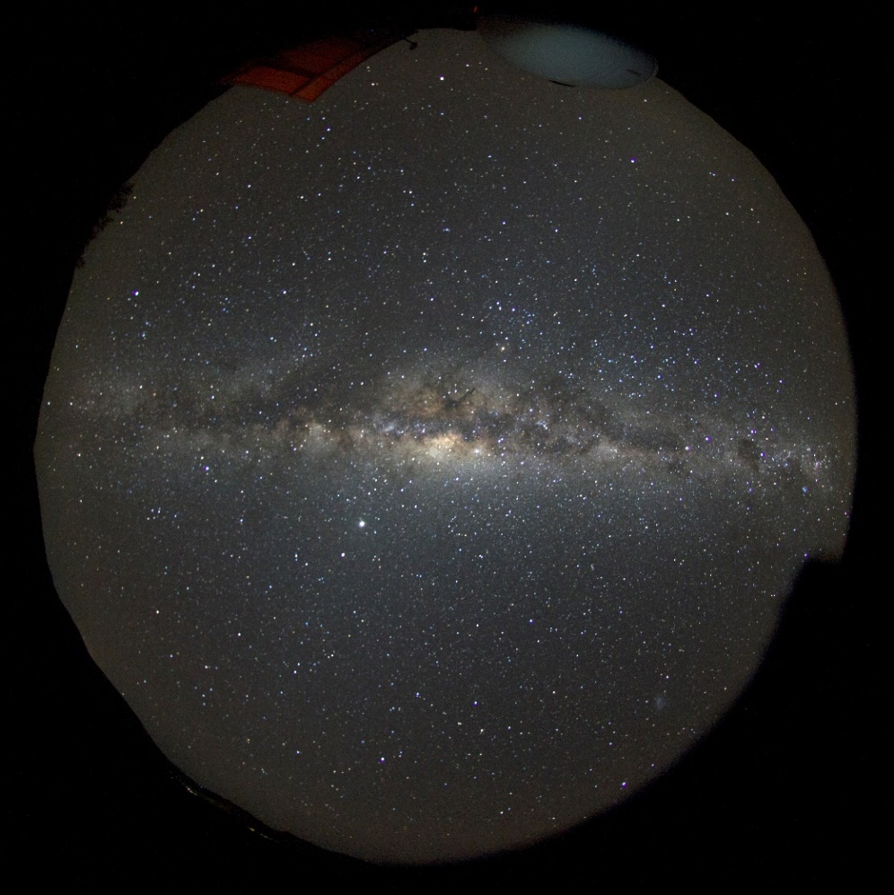
All sky image of the Milky Way at the zenith from Spriggina

Lighting Management Plan

Lighting Management Plan Policy
The overarching principles which have been and will continue to be applied to all outdoor lighting on Arkaroola includes:
- the use of low wattage lighting sufficient to provide staff and guest safety of movement at night and
- complying with the Australian Lighting Standard 4282-1997 ‘Control of the obtrusive effects of outdoor lighting’ and with the ‘Safer by design’ guidelines prepared by the NSW Police.
A balance must be obtained between the safety of our staff and guests and the maintenance of our dark night skies. To this end, the Arkaroola ‘Dark Skies Sanctuary’ Company Policy, implemented in March 2005 and updated in 2021, provides guidelines to be followed by Arkaroola in the maintenance and upgrade of lighting on the property, and the education of guests.

Risks and Threats
The nearest significant settlement is the Beverley Uranium Mine (see https://en.wikipedia.org/wiki/Beverley_Uranium_Mine), located just to the east of Arkaroola’s eastern boundary on the neighbouring Wooltana Station, 26 kilometres north east of the Arkaroola Village at 30° 11.5’ south, 139° 35.9’ east. It is owned by Heathgate Resources Pty Ltd (see http://www.heathgate.com.au/thebeverleymine.html), an Adelaide-based company, that is part of the US-based General Atomic group of companies. It employs approximately 150 people, operating on a fly-in, fly-out (FIFO) basis.
The mining utilises low-impact an in-situ leaching process. Although we can detect minor light pollution from high pressure sodium vapour outdoor lighting used at Beverley on cloudy nights, sky degradation has not been detected on clear dark nights. Beverley Mine is not visible from Arkaroola Village because of the rugged mountainous terrain between the two sites.
Heathgate Resources pride themselves as a company utilising world’s best practice and Arkaroola are currently involved in discussions with senior management with a view to reducing their dark sky impact now and into the future. Recently they have turned off all unnecessary lighting at well fields not in use, and are considering more appropriate lighting for their future developments. We are hopeful of even more successful outcomes.
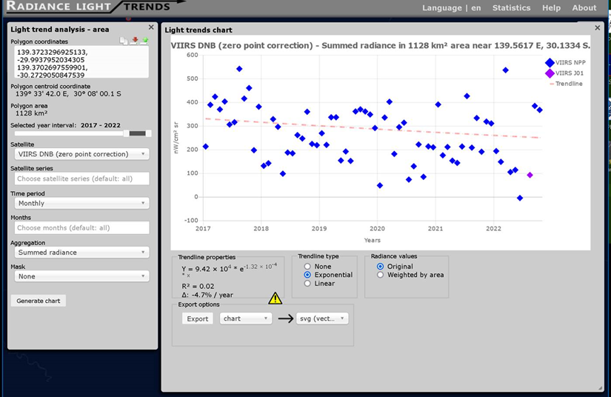
Beverley Uranium Mine is reducing their dark sky impact

Plans
Arkaroola is fully committed to the objectives and goals of the International Dark- Sky Association (IDA), including having more than 90% of all exterior lighting fully conforming with the Arkaroola ‘Dark Skies Sanctuary’ Company Policy and Lighting Management Plan Guidelines by December 2022 and 100% conforming by March 2024 (see Planned Lighting Actions).

Future Activities
Should Arkaroola be awarded International Dark Sky Sanctuary status, it will include such identification on entrance signage to the property, the reception building and all of Arkaroola’s astronomical observatories, as well on our website and in our visitor welcome packs.
The Proposed World Heritage Listing can lead to many benefits, including regional economic development, increased tourism opportunities and visitations, increased employment opportunities and income, improved planning and management of the region and improved management and protection of the local environment, enhanced protection of the rich cultural landscape and cultural sites, and First Nations peoples and communities. Once included on the World Heritage List, the Flinders Ranges World Heritage Serial Property, including Arkaroola, will be protected by the Australian Government’s Environment Protection and Biodiversity Conservation Act 1999 (EPBC Act). Approval is required under the EPBC Act for any action that is likely, has or will have a significant impact on the Outstanding Universal Value of a World Heritage listed place, such as construction; mineral and petroleum resource exploration and extraction; storage or transport of hazardous materials; waste disposal and earthworks and so on.
Should any expansion be required, Arkaroola hereby provides a positive commitment to the maintenance of its dark skies and to the adherence of the Lighting Management Plan and to ensure existing or improved lighting facilities minimise any impacts upon Arkaroola’s pristine dark sky environment.
Arkaroola will continue to use its permanent fixed Unihedron Sky Quality Meter continuous monitoring station at the Oliphant Observatory, as well as conduct spot data collection around the property at least annually to quantify sky darkness for inclusion in its annual report to IDA.
Mr Douglas Sprigg, the formal Point of Contact person, will keep the IDA fully advised of the progress of any action required, with photographic evidence, as mentioned above.

APPENDICES

Letter of Nomination

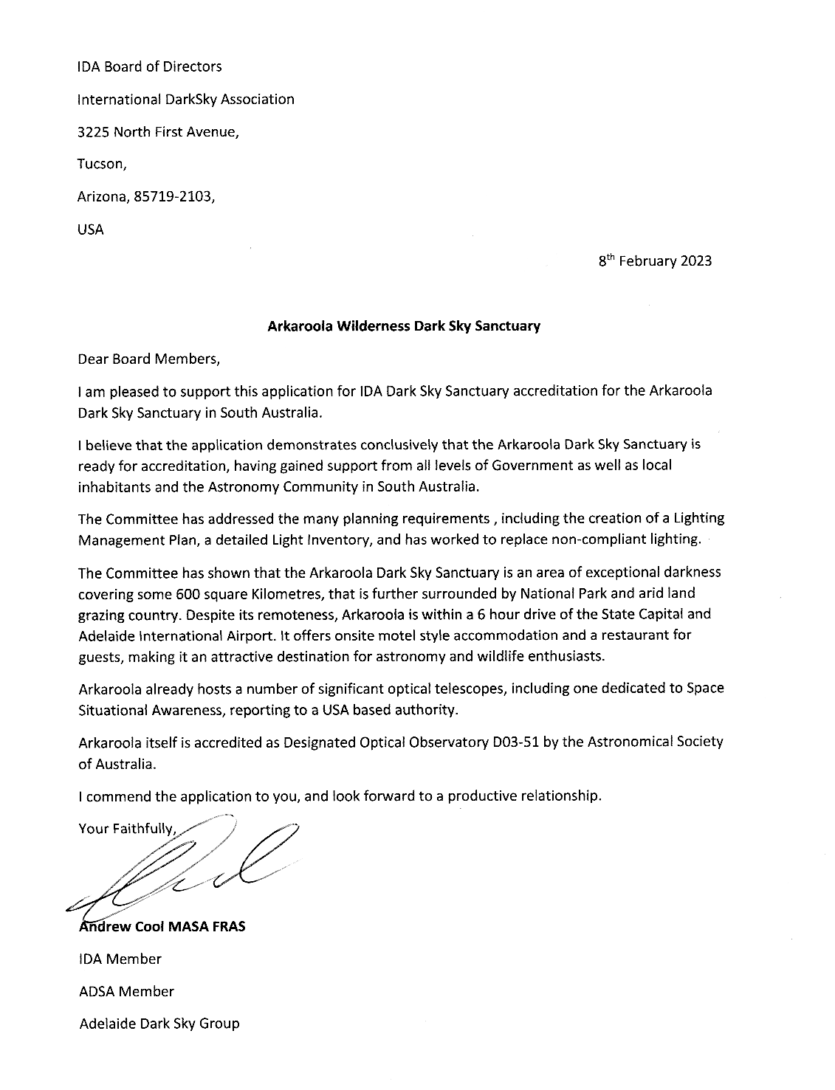

Letters of Support

Hon Steven Marshall MP, Premier of South Australia (2018-2022)
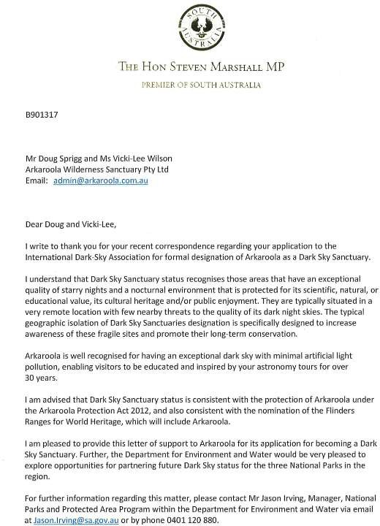

Hon Sussan Ley MP, Member for Farrer, Minister for the Environment (2019-2022)
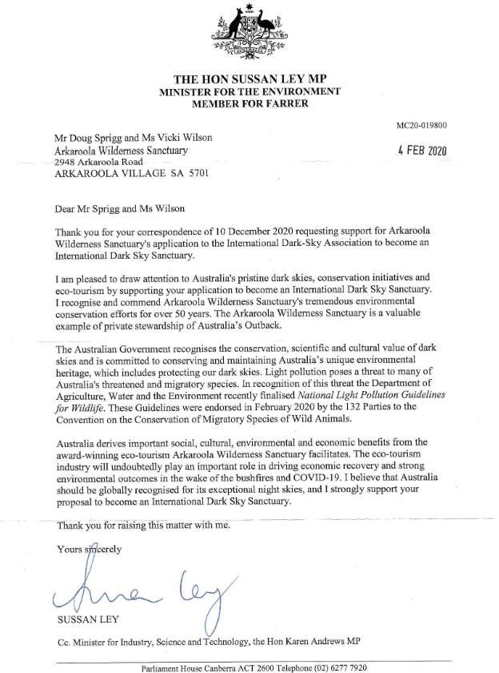

Hon Dan van Holst Pellekaan MP, Member for Stuart, Minister for Energy & Mining (2010-2022)

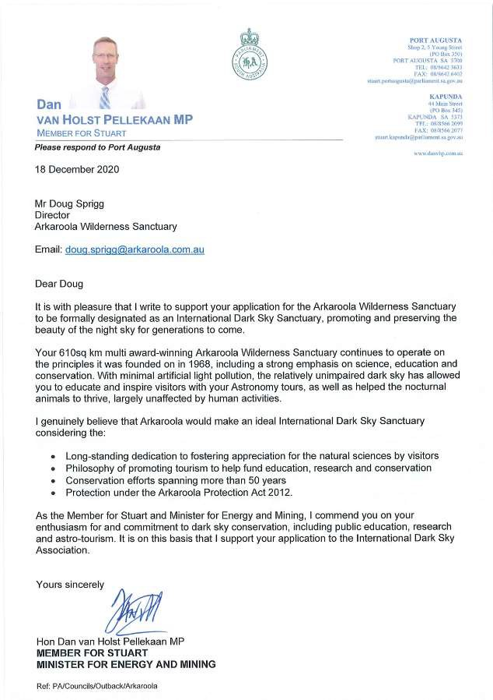

Rowan Ramsey MP, Federal Member for Grey
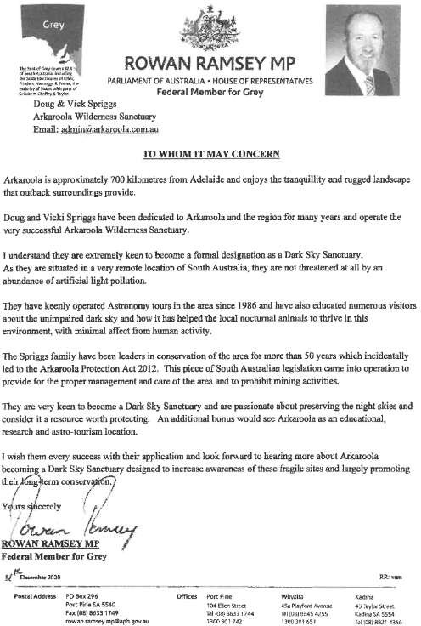

Malcolm Walter PhD AM FAA FGSAust

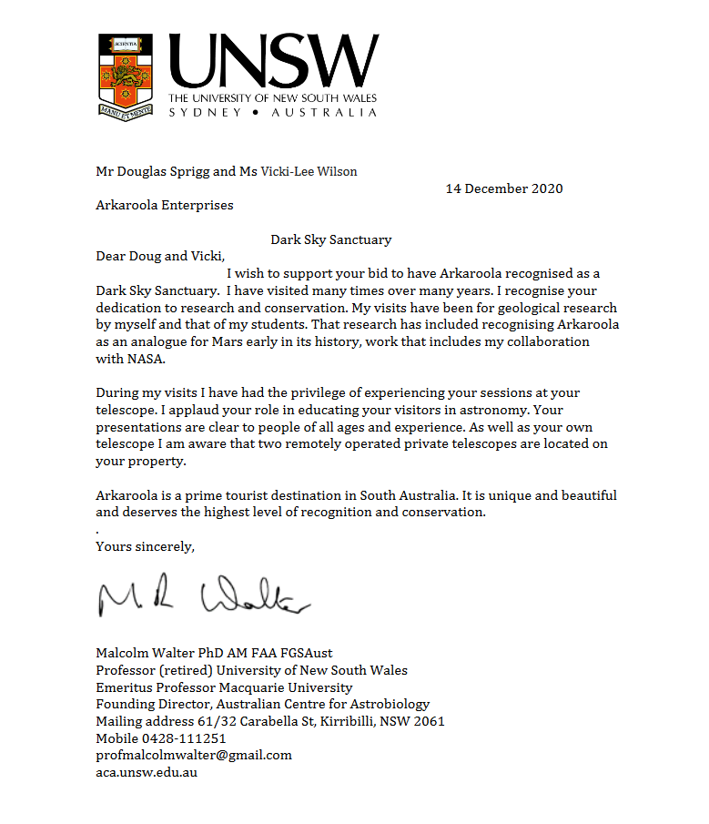

Manual Lois MD, PCCP, FACP
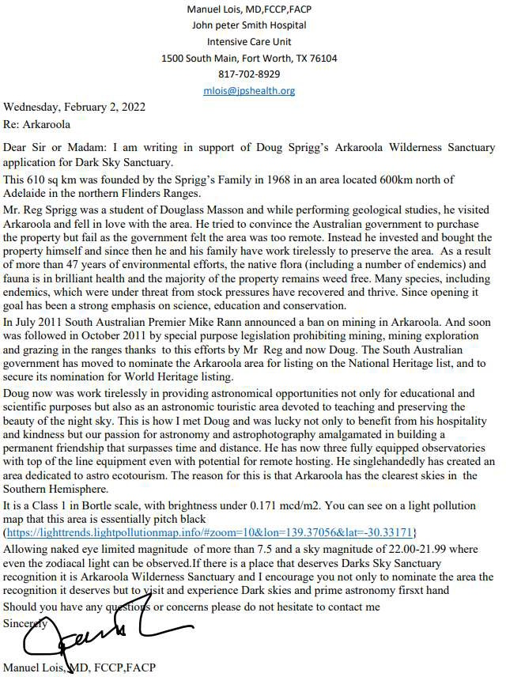

Harald Ehmann, Arkaroola Wildlife Ecologist (Honorary)
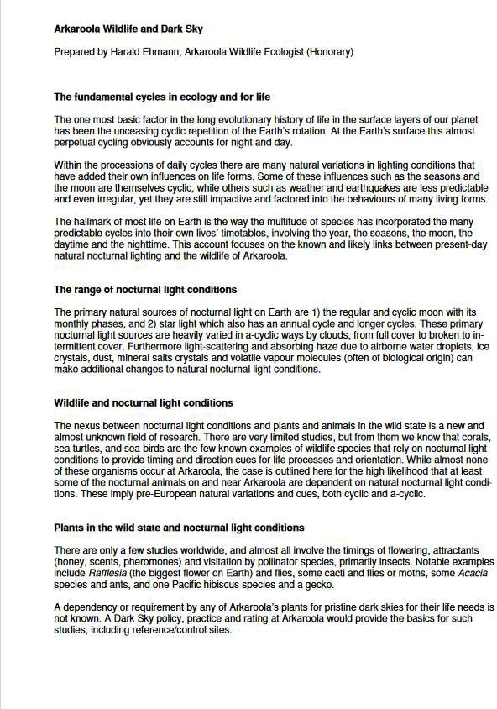

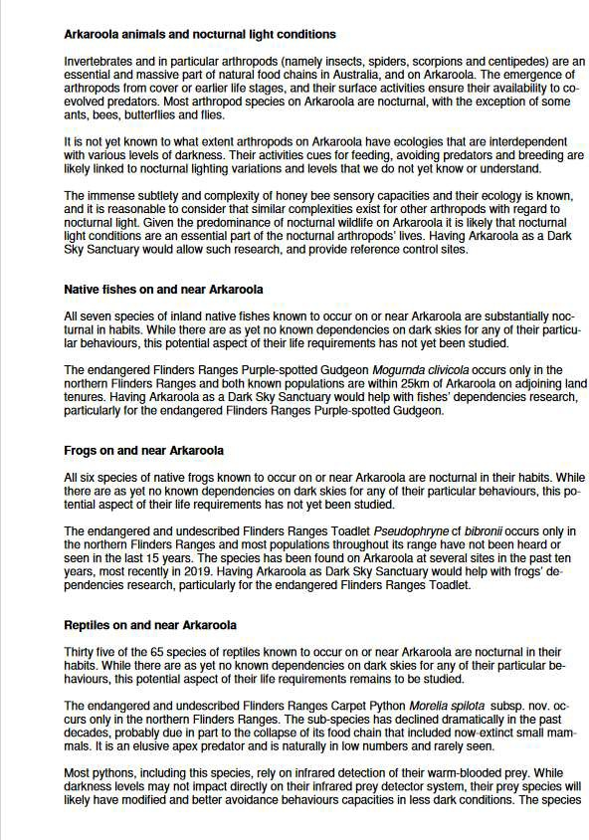

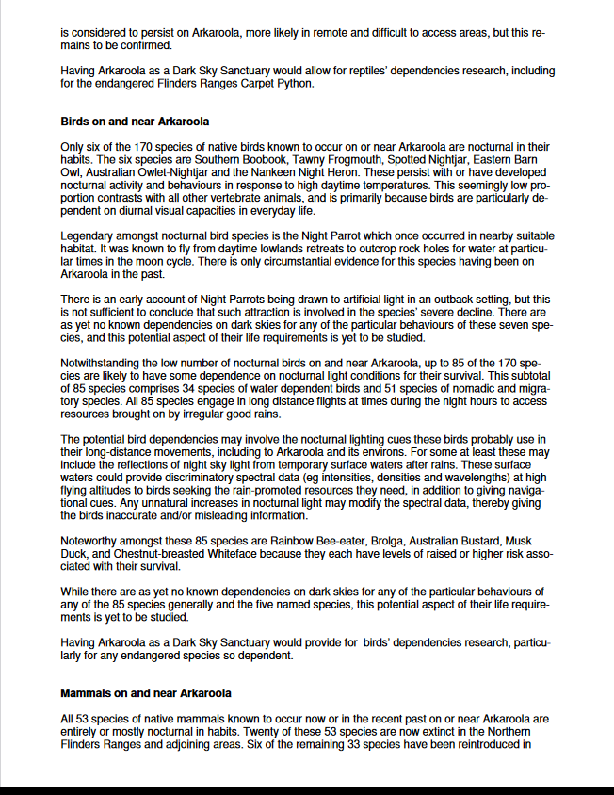

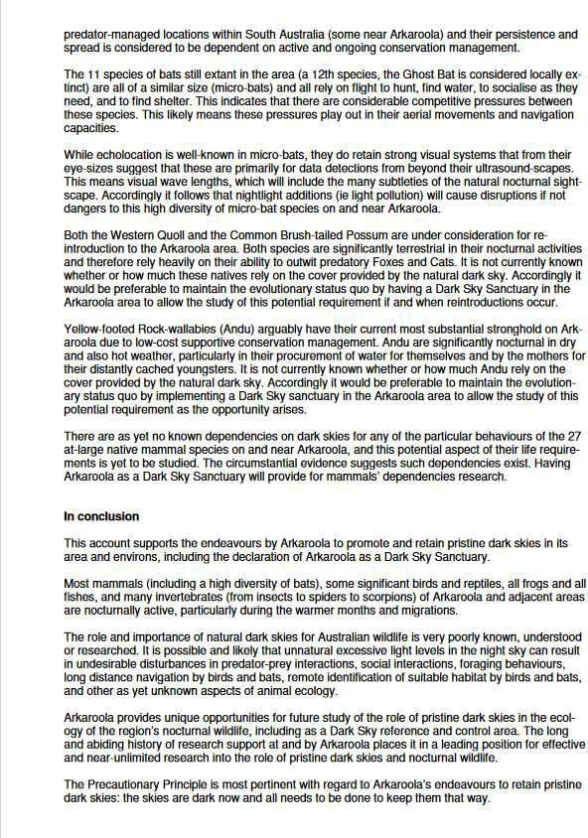

Dr Eric Benson
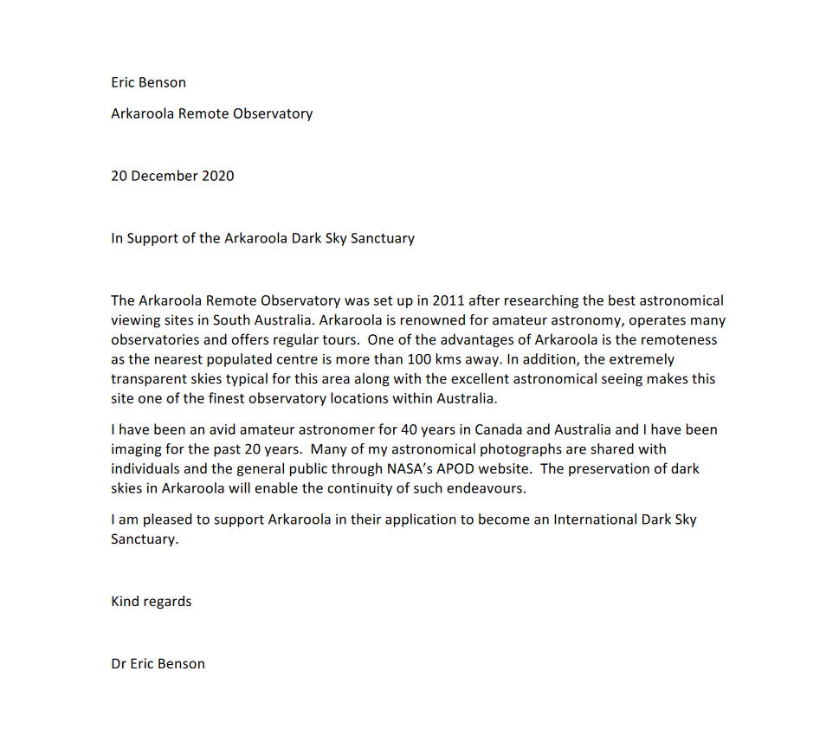

Mark Wielgosz
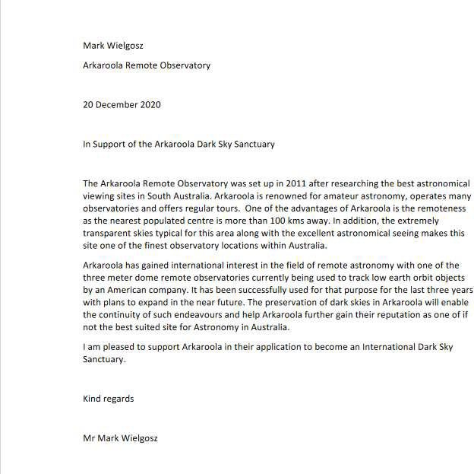

Padraic Koen
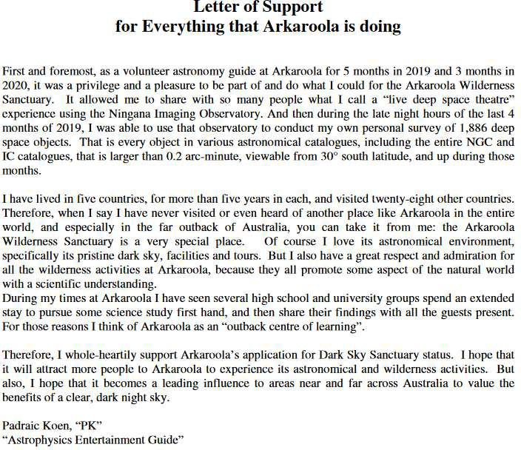

Conformity to IDSS Goals and Criteria Details
The following sub-sections address the conformity of Arkaroola to the IDSS Goals and Criteria and provides links to further information contained within this document.

Goals for International Dark Sky Sanctuary Creation

Goal | Conformity | Reference
To recognize public or private lands and their surrounding communities in some of the darkest locations on Earth for exceptional commitment to and success in local implementation of the ideals of dark sky preservation | Arkaroola intends to retain dark skies for the circadian rhythms of life as well as astronomy, and promote the land and sky for all. | 4.3, Historical Overview
To promote sustainable ecotourism and astrotourism | Arkaroola’s objectives include increasing guests’ enjoyment and appreciation of our unique sanctuary, foster their understanding of the importance of dark skies, and enhancing our advanced ecotourism accreditations. | 11.1, Arkaroola ‘Dark Skies Sanctuary’ Company Policy  4.5.1, Astronomical Activities
 | We run four fully equipped astronomical observatories, all of which are designed and operated to ensure an unforgettable “Stargazing” experience. In addition to conducting Advanced Ecotourism Accredited Astronomy Tours, each of our observatories are available to professional and amateur astronomers, and to visiting astronomical societies and clubs.
To further the protection of nocturnal habitats, public enjoyment of the night sky and its heritage, and identification of areas ideal for professional and/or amateur astronomy | Arkaroola intends to retain dark skies for the circadian rhythms of life as well as astronomy, and promote the land and sky for all.  Each of our observatories are available to professional and amateur astronomers, and to visiting astronomical societies and clubs. | 4.2, Aims of Arkaroola 4.5.1, Astronomical Activities
To encourage land owners/administrators, conservation professionals, surrounding communities and private interests to identify dark skies as a valuable resource in need of proactive conservation | The purchase of Arkaroola was aimed at preserving the uniqueness of the rugged mountainous landscape, its flora, fauna, geology and night skies for all to enjoy. | 5.1, Dark-Sky Management Policy
To provide international recognition for such locations | This application aims to achieve IDA accreditation as one of the darkest locations on Earth and its exceptional commitment to and success in the preservation of the dark sky. | 2.4, Intended Audience specifically the IDA

Goal | Conformity | Reference
To encourage other sites to become environmental leaders on dark sky issues by communicating the importance of dark skies and by providing an example of what is possible with proper stewardship | This application aims to promote the importance and value of dark sky places to visit digitally or physically. | 2.4, Intended Audience specifically future applicants and the general public.

Eligibility Criteria

Eligibility Criteria | Conformity | Reference
1 A proposed IDSS must be a public or a private land legally protected for scientific, natural, educational, cultural, heritage or public enjoyment purposes. | In 2012 the State Government enacted the Arkaroola Protection Act, part of which protects the Arkaroola pastoral lease from future mining activities.  Arkaroola is the only wildlife sanctuary or national park in South Australia to be so protected against mining. | 4.3.4, Recent Developments
2 The IDSS must provide an opportunity for regular public nighttime access, with or without supervision. A portion of designated land may meet this requirement, or access must be available for a substantial fraction of given night. In some cases, such as when working with areas that protect endangered wildlife, archaeological sites, or other sensitive resources, this requirement may be waived or adjusted to meet important conservation goals. | Arkaroola runs four fully equipped astronomical observatories, three located well above the village area and one conveniently located very close to our Reception area.  Visitors to Arkaroola have access to these observatories and are encouraged to either bring their own telescopes or to join one of the Observatory Tours on offer.  Visitors can also travel freely on designated tracks in the southern part of the property. There are no public tracks in the high-value conservation, northern part of the property. | 4.5.1, Astronomical Activities  4.4.3, Astronomical Facilities
3 In order to ensure public accessibility on private lands, the landowner(s) must allow the public to transit any part(s) of the property not included in the formally declared IDSS as required to reach designated viewing areas.
4 The Sanctuary must provide an exceptional dark-sky resource where the night-sky brightness at the zenith is routinely equal to or darker than 21.5 magnitudes per square arc second in the visual band and where significant light domes are not present toward the local horizon in any direction. | Data logged since September 2017 by a fixed continuous reading Unihedron Sky Quality Meter monitoring station reveals that:  - 52% of all readings between 9pm and 4am are greater than or equal to 21.5 magnitudes per square arc second, and  - 78% of all nights had at least one reading are are greater than or equal to 21.5 magnitudes per square arc second. | 13, Night-Sky Brightness Study Details

Minimum Requirements

Minimum Requirement | Conformity | Reference
1 A quality comprehensive Lighting Management Plan (LMP) must be adopted by the agency administering the proposed IDSS. The LMP regulations must be binding upon all private and public landowners within the area of protection. Certain exceptions to this requirement may apply but are subject to IDA approval.  Minimum standards are described below in the section titled “Lighting Management Plan Guidelines”. | The Arkaroola ‘Dark Skies Sanctuary’ Company Policy, appendix 11, first made in March 2005 and updated in 2021, provides guidelines to be followed by Arkaroola in the maintenance and upgrade of lighting on the property. | 5.4.1, Lighting Management Plan Policy
2 Evidence of commitment to dark skies and quality outdoor lighting as demonstrated by at least two-thirds (67%) of existing outdoor lighting fixtures in the IDSS conforming to the requirements of the Lighting Management Plan at the time of application. | The Lighting Management Plan demonstrates that 90% of existing lighting conforms to IDSS requirements. | 12, Lighting Inventory Details
3 A schedule denoting that 90% of all outdoor lighting in the IDSS will conform to the Sanctuary’s LMP within five years of receipt of an IDA designation and a written commitment that 100% of the lighting will conform within ten years of the designation. | The Lighting Management Plan demonstrates that 90% of existing lighting conforms to IDSS requirements. Plans are in place to achieve 100% conformance by March 2024. | 12.1, Lighting Inventory  12.4, Planned Lighting Actions
4 A sky brightness measurement program must be established and maintained either by the Sanctuary administering authority or by another public or private organization (university, research center, IDA chapter, astronomy club, etc.) to follow the evolution of light pollution in the IDSS and ensure that the night sky quality does not degrade over time.  Applicants are encouraged, but not required, to submit their measurements to the citizen science projects such as My Sky At Night (myskyatnight.com) and Globe At Night (globeatnight.org) | Arkaroola has had a permanent fixed monitoring station operational since September 2017 | 13.1, Long-Term Night-Sky Brightness Monitoring
5 A description of current and potential future threats to dark skies over the Sanctuary. | The only significant establishment within 100 kms of Arkaroola is the Beverley Uranium Mine north east of the Arkaroola Village. | 5.4.2, Risks and Threats

Minimum Requirement | Conformity | Reference
6 The importance of dark skies/natural darkness and the benefits of quality lighting are paramount in Sanctuary external communications. If the Sanctuary typically provides interpretive programs, then dark skies must be one of the central themes communicated through on-site interpretation. If interpretive programs are not typically offered, then publications, flyers, press releases, media, or other outreach are appropriate substitutes. | We run four fully equipped astronomical observatories, three located well above the village area and one conveniently located very close to our reception area. All of our observatories are designed and operated to ensure an unforgettable “Stargazing” experience.  The Arkaroola Welcome Pack explicitly requests visitors to “help reduce impacts on wildlife and aid the astronomy operations in the area by keeping bright lights to a minimum and avoid pointing them upwards.” It also invites visitors to “take the opportunity to enjoy our dark sky environment.” | 4.5.1, Astronomical Activities  11.6, Guests Use of Lighting and Nocturnal Activities
7 Dark skies in the protected area are acknowledged as an important scientific, natural, cultural, and/or scenic resource value by jurisdictions higher than community level (e.g., county, province, state, etc.), as shown by the inclusion of appropriate language in official documents. | Letters of support have been obtained from the Premier, the Minister for the Environment, and the Minister for Energy, and Mining of South Australia, a Federal Minister, a wildlife ecologist, and several astronomers. | 7, Letters of Support
8 Once established, the Sanctuary must erect and maintain appropriate signage indicating the International Dark Sky Sanctuary designation along a roadway entrance, along a footpath entrance if no roadway exists, or in a similar setting. If approved by IDA, language as an alternative to “International Dark Sky Sanctuary” may appear on the signage and in Sanctuary communications regarding the IDSS status. Once the sign is erected a photograph documenting this sign must be taken and sent to IDA for records along with a description of its location. | Should Arkaroola be awarded International Dark Sky Sanctuary status, it will include such identification on entrance signage to the property, the reception building and all of Arkaroola’s astronomical observatories, as well on our website and in our visitor welcome packs. | 5.4.4, Future Activities
9 Night-sky quality is established through:  A) The core of the Sanctuary must have identified the sources of light pollution through calculations, maps, photographs or any other proper method AND clearly identify actual present and anticipated future threats to the night sky quality. A plan must be put in place to address these current and future threats. | Immediately prior to this submission, Arkaroola management undertook a full inventory of all outdoor lighting within the property, and planned for the remediation of all non- conforming lighting.  Arkaroola has had a permanent fixed Unihedron Sky Quality Meter monitoring station operational since September 2017. | 10.5, Night Sky Light Pollution Maps  12.1, Lighting Inventory  13, Night-Sky Brightness Study Details  5.4.2, Risks and Threats  12.4, Planned Lighting Actions

Minimum Requirement | Conformity | Reference
B) A determination of whether the minimum sky quality standard has been met through sky brightness measurements made via an IDA-approved data collection method. Measurements must be distributed over a sufficiently long enough period of time in order to average out fluctuations over timescales ranging from nights to seasons in length. Applicants should discuss their measurement protocol with the International Dark Sky Places Program Manager. | Arkaroola are currently involved in discussions with senior management of the Beverley Uranium Mine, the only significant establishment within 100 kms., with a view to reducing their dark sky impact now and into the future. Recently they have turned off all unnecessary lighting at well fields not in use, and are considering more appropriate lighting for their future developments. We are hopeful of even more successful outcomes.

Other Criteria

Other Criteria | Conformity | Reference
1 Designate a formal point-of-contact person. | Full contact details provided. | 2.3, Point of Contact
2 Obtain a letter of nomination from a qualified IDA member nominator, as well as a supporting letter from the Sanctuary managing agency. | Letter obtained | 6, Letter of Nomination
3 Provide additional letters of support from community organisations, clubs, groups etc | Letters of support have been obtained from:  - the Premier of South Australia,  - the Minister for the Environment, the Minister for Energy,  - the Minister for Mining,  - a Federal Minister,  - a wildlife ecologist, and  - several astronomers. | 7, Letters of Support
4 Maps of the area indicating the Sanctuary’s legal boundaries and its geographic context. | Maps provide Arkaroola’s:  - Location in Australia and South Australia,  - Pastoral Lease Boundaries,  - Village layout,  - Darkness at night via satellite, and  - Inclusion in the Proposed Flinders Ranges World Heritage Serial Property Map. | 10, Maps
5 Provide management documents supporting dark skies and natural nighttime darkness as a valued natural resource. | The Arkaroola ‘Dark Skies Sanctuary’ Company Policy, Appendix 11, was adopted by Arkaroola management in 2005 and updated in 2021 in order to preserve the unpolluted darkness of Arkaroola’s night skies and has formed the basis of our Light Management Plan. | 5.1, Dark-Sky Management Policy

Other Criteria | Conformity | Reference
6 Lighting inventory plan | Immediately prior to this submission, Arkaroola undertook a full inventory of all outdoor lighting within the property. | 12, Lighting Inventory Details
7 Any documentation of the cultural/historical/scientific significance of the Sanctuary and ongoing efforts to preserve and promote these resources. | Arkaroola Wilderness Sanctuary and our not-for-profit entity, the Arkaroola Education and Research Foundation NGO, are committed to research, conservation, education and the promotion of all natural sciences. | 4.2, Aims of Arkaroola 4.3, Historical Overview  4.3.4, Recent Developments
In 2012, the State Government enacted the Arkaroola Protection Act, part of which protects the Arkaroola pastoral lease from future mining activities.
Arkaroola is the only wildlife sanctuary or national park in South Australia to be so protected against mining.
 | The recent Energy Grant will add remote energy technology and engineering to the list of educational experiences.
 | The Proposed World Heritage Listing can lead to many benefits, including regional economic development, increased tourism opportunities and visitations, increased employment opportunities and income, improved planning and management of the region and improved management and protection of the local environment, enhanced protection of the rich cultural landscape and cultural sites, and First Nations peoples and communities.

Other Criteria | Conformity | Reference
8 A summary of future plans for activities in the Sanctuary after receiving IDA certification. | Should Arkaroola be awarded International Dark Sky Sanctuary status, it will include such identification on entrance signage to the property, the reception building and all of Arkaroola’s astronomical observatories, as well on our website and in our visitor welcome packs.  Should any expansion be required, Arkaroola hereby provides a positive commitment to the maintenance of its dark skies and to the adherence of the Lighting Management Plan and to ensure existing or improved lighting facilities minimise any impacts upon Arkaroola’s pristine dark sky environment. | 5.4.4, Future Activities

Lighting Management Plan Guidelines

Lighting Management Plan Guideline | Conformity | Reference
1 The written policy meets or exceeds applicable agency or departmental policies regarding outdoor lighting and conforms to all applicable local, regional, and national laws. | The overarching principles which have been and are to be applied to all outdoor lighting on Arkaroola includes:  - the use of low wattage lighting sufficient to provide staff and guest safety of movement at night, and  - complying with the Australian Lighting Standard 4282-1997 ‘Control of the obtrusive effects of outdoor lighting’ and with the ‘Safer by design’ guidelines prepared by the NSW Police. | 5.4, Lighting Management Plan
2 The use of outdoor light at night is only prescribed when it is strictly needed, where it is needed, and in the appropriate amount for a specific task. The purpose of outdoor light that is allowed under the policy should be specifically to ensure public safety. | The Arkaroola ‘Dark Skies Sanctuary’ Company Policy specifically states that exterior lighting is not to exceed the minimum number necessary to safely and adequately light a specific area.  The Lighting Inventory Details shows all operational lighting is deemed to be acceptable or appropriate for the purposes and times of use without interfering with our astronomy tours or other nocturnal tours and activities. | 11.2, Exterior Lighting  12, Lighting Inventory Details

Lighting Management Plan Guideline | Conformity | Reference
3 All outdoor lighting fixtures must be fully shielded, irrespective of purpose or the number of lumens of light it emits, and make appropriate use of timers and motion sensors;. Lighting controlled with motion- activated switches limiting the duration of illumination to less than five (5) minutes after activation is exempt from the other requirements of this section. | The Lighting Management Plan includes plans to fully comply with IDSS lighting requirements by March 2024 including installing LED movement sensor lights in the Caravan Park and at Dodwell Observatory | 12.4 Planned Lighting Actions
4 Lighting must be chosen to minimize the amount of short-wavelength light emitted into the nighttime environment. The Sanctuary’s LMP must restrict lighting in this respect according to one of the following prescriptions:  - The correlated color temperature (CCT) of lamps must not exceed 3000 Kelvins; OR  - Allowed lighting must not emit more than 25% of its total spectral power at wavelengths < 550 nanometers; OR  - The scotopic-to-photopic (S/P) ratio of allowed lighting must not exceed 1.3.These metrics may be found listed in manufacturer data sheets for lighting products. | The Arkaroola ‘Dark Skies Sanctuary’ Company Policy explicitly states that exterior lighting must be low output (wattage) lighting, making use of state-of-the-art technologies such as LED, CFL and similar lighting with a correlated colour temperature (CCT) range between 2000 and 3000 kelvin. | 11.2, Exterior Lighting
5 Visitor activities with respect to the introduction of unnecessary artificial light at night into the Sanctuary environment are regulated. This must include reasonable limits on the lighting of camping equipment and recreational vehicles, as well as a general prohibition of inappropriate “light painting” and similar. Note that this requirement is in no way intended to compromise visitor safety. | The Arkaroola ‘Dark Skies Sanctuary’ Company Policy explicitly states that guests are asked to assist Arkaroola in the maintenance of its pristine dark night skies. | 11.6, Guests Use of Lighting and Nocturnal Activities
6 Operation of illuminated signs, except those strictly required for wayfinding, is prohibited. Any permitted illuminated signs shall adhere to the following regulations:  - Displays must be single-color on a black background; AND  - Luminance after sunset may not exceed 100 nits (100 candelas per square meter). | There are no illuminated signs on the property.  The Arkaroola ‘Dark Skies Sanctuary’ Company Policy explicitly states that the operation of illuminated signs, except those strictly required for wayfinding, is prohibited. | 12.1, Lighting Inventory  11.2.4, Illuminated Signs

Background of Arkaroola

The Legend of Arkaroo
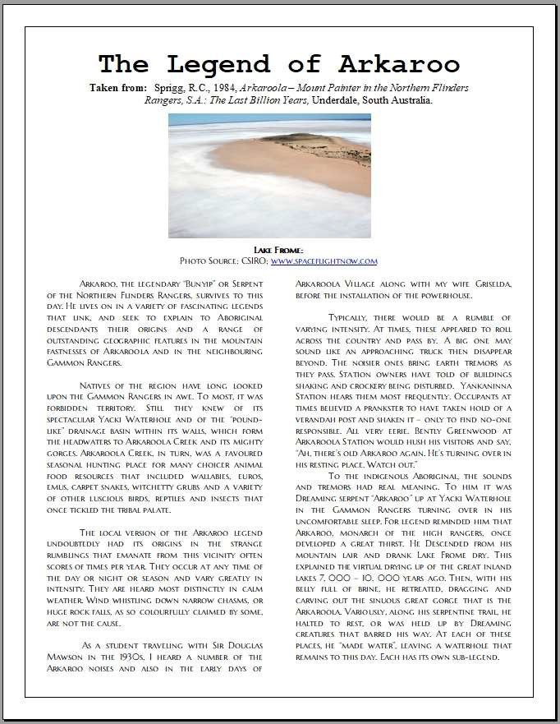

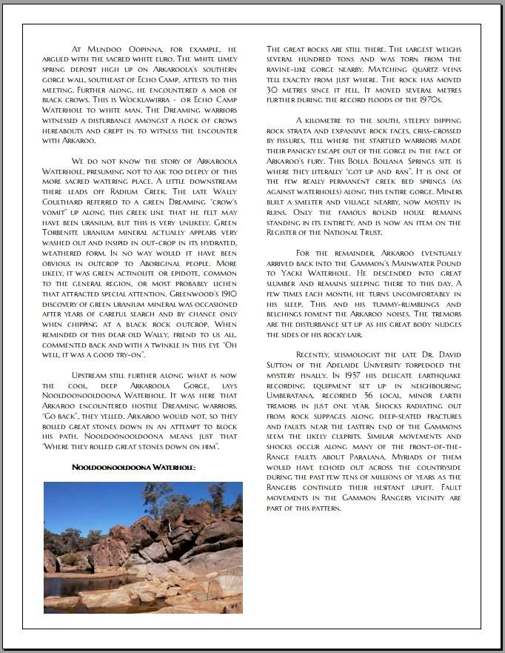

Arkaroola – Mt. Painter Wilderness Sanctuary – A Brief History
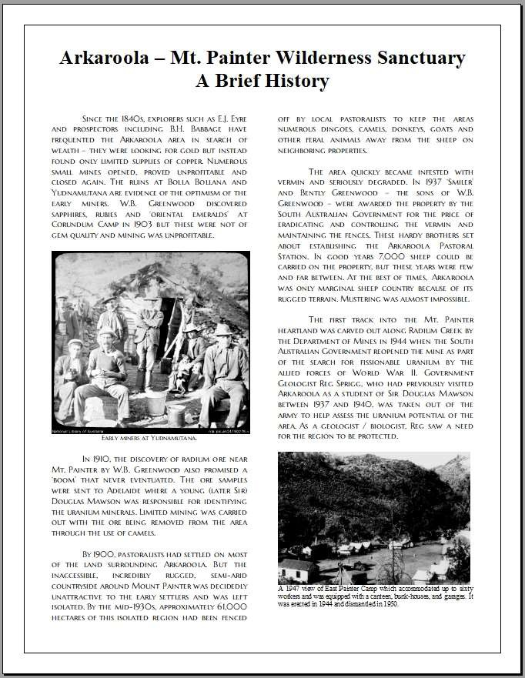

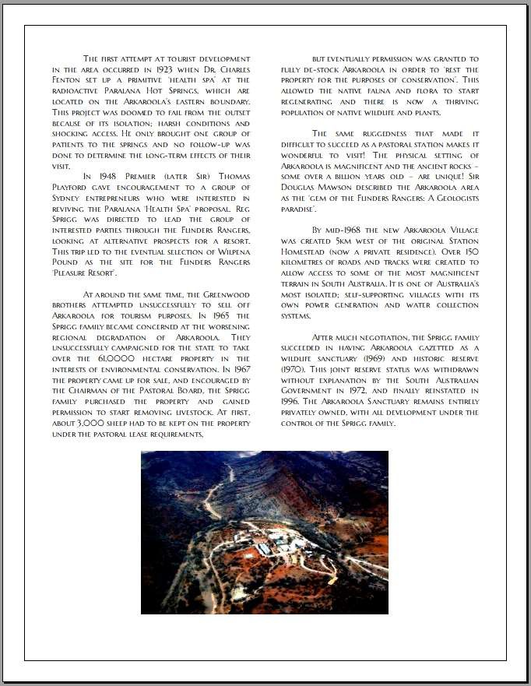

Maps

Australia
Map from Google Maps.
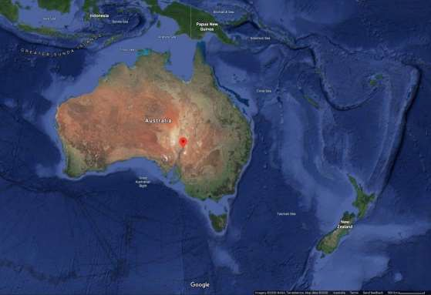

South Australia
Map from Google Maps.
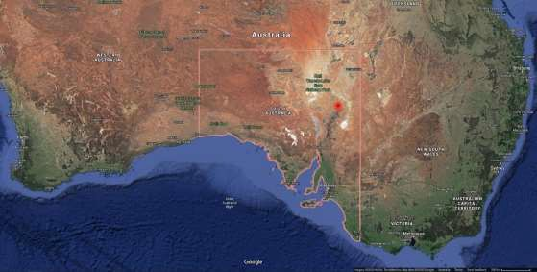

Arkaroola Pastoral and Freehold Lease Boundaries
Although the map below shows the highlighted Arkaroola Protection Area as per the Arkaroola Protection Act 2012 (SA), it needs to be noted that Arkaroola’s northern boundary extends northward of the northern boundary of the Arkaroola Pastoral Lease area. The actual boundary of the Arkaroola Pastoral Lease is that area marked as ‘Arkaroola PL’, the boundary of which is shown by the green coloured lines. The Arkaroola Freehold Lease covers the area marked as ‘Arkaroola Village’. North is the top of the map.
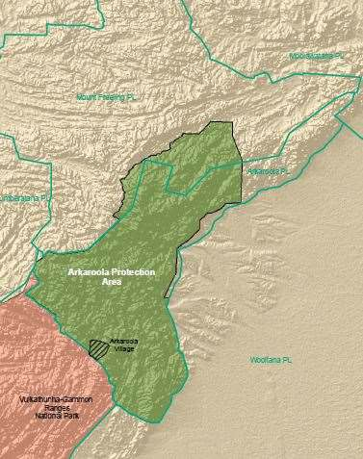

Arkaroola Village
Satellite view from Google Maps.
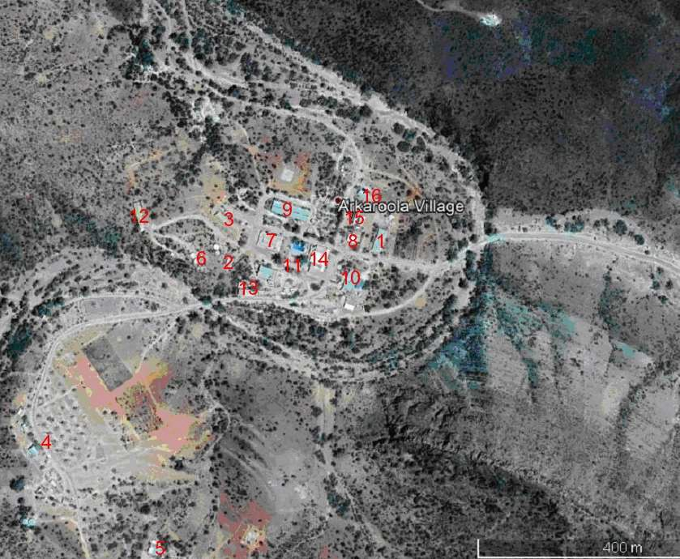

ID | Name | ID | Name
1 | Broughton Lodge | 9 | Mawson Lodge
2 | Callana Cottage | 10 | Ningana Interpretive Centre
3 | Callitris Lodge | 11 | Outdoor Entertainment Area
4 | Caravan-Camping Grounds inc. bunkhouses | 12 | Owner’s Residence
5 | Fauna House | 13 | Powerhouse
6 | Dodwell Observatory | 14 | Reception and Restaurant
7 | Greenwood Lodge | 15 | Thomas Wing
8 | Manager’s Residence | 16 | Wallaby and Euro Cottages

Night Sky Light Pollution Maps
Images from https://www.lightpollutionmap.info
    - Southern Australia
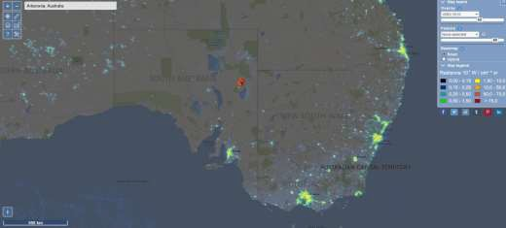
    - Within 200 kms
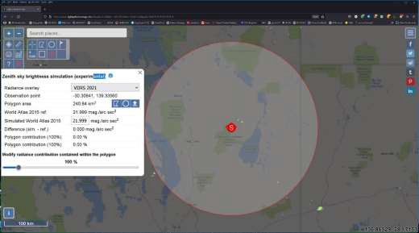

    - Within 100 kms with 25 km concentric rings
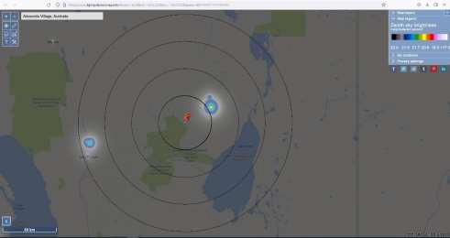
    - Within 10 kms with 5 km concentric rings
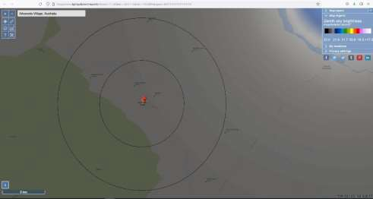

Topographic Map
Map from https://en-au.topographic-map.com
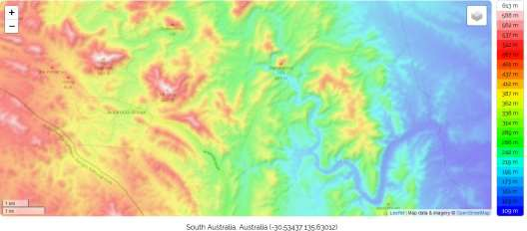

Proposed Flinders Ranges World Heritage Serial Property Map
Map from https://cdn.environment.sa.gov.au/environment/docs/flinders-ranges-world- heritage-map.pdf
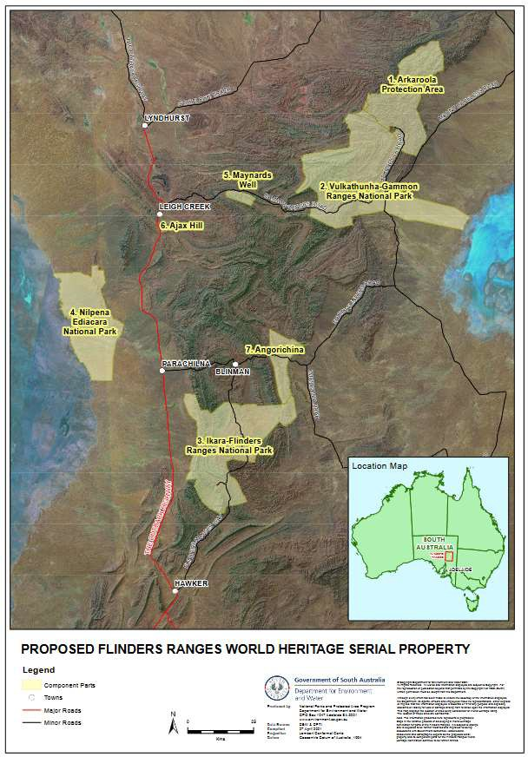

Arkaroola ‘Dark Skies Sanctuary’ Company Policy
In 2005, Arkaroola management created a dark skies policy in order to preserve the unpolluted darkness of Arkaroola’s night skies. In 2021 that policy was updated to fully conform with IDSS Lighting Management Plan Guidelines.

Objectives
Arkaroola Wilderness Sanctuary is a ‘Dark Skies Sanctuary’ to: Reduce light pollution, to enhance Arkaroola’s nocturnal tours, namely:
- Astronomy tours, and
- Other nocturnal tours and activities;
- Increase guests’ enjoyment of our unique sanctuary;
- Enhance our advanced ecotourism accreditations;
- And reduce costs associated with wasteful lighting.
Company Management and all Employees are to ensure that the requirements of this Policy are adhered to at all times.

Exterior Lighting
Not to exceed the minimum number necessary to safely and adequately light a specific area; this has been determined as being:

Pathways
- Low voltage, low output (wattage) lighting, making use of state-of-the-art technologies such as LED, CFL and similar lighting with a correlated colour temperature (CCT) range between 2000 and 3000 kelvin
- Solar powered lighting (pathway, area etc) – not to exceed 3 watts equivalent power output
- To be fully shielded, such that effective top and side shielding prevents stray lighting of unintended areas
- Minimal number of lighting units conducive to safety and the maintenance of this policy

Safety and Security Lighting – building exterior, veranda, etc
- Not to exceed 15 watts or equivalent power output and to be of a CCT between 2000 and 3000 kelvins
- Make use of economical ‘fluorescent replacement’ types – with maximum 15 watts equivalent power rating
- To be fully shielded, such that effective top and side shielding prevents stray lighting of unintended areas
- Minimal number of lighting units conducive to safety and the maintenance of this policy

Street and Road Lighting
- Where necessary for safety, make use of state-of-the-art technologies such as LED, CFL and similar lighting with a CCT between 2000 and 300 kelvin
- To be fully shielded, such that effective top and side shielding prevents stray lighting of unintended areas
- Where fitted to buildings or other fixtures, not to be mounted more than 5 metres above the area intended to be lit
- Maximum light output – 50 watts equivalent power or similar
- Minimal number of lighting units conducive to safety and the maintenance of this policy

Illuminated Signs
Operation of illuminated signs, except those strictly required for wayfinding, is prohibited. Any permitted illuminated signs shall adhere to the following regulations:
- Displays must be single-color on a black background, and
- Luminance after sunset may not exceed 100 nits (100 candelas per square meter)

Geographical or Geological and Natural Features
If required to illuminate above 5 metres (as in the case of Griselda Hill), all such lighting to be:
- Make use of state-of-the-art technologies such as LED, CFL and similar lighting with a CCT between 2000 and 3000 kelvins
- Not to exceed the minimal lighting required to affect the intended aesthetics, or to enhance the nocturnal view, of such features
- To be activated by infrared switching to switch ‘on’ at dusk and switch off no later than 10.00pm or earlier depending on nocturnal guided tours and other activities requiring minimal light pollution. When in doubt, switch it off!
- To be fitted with effective side and other shielding as necessary to reduce unwanted stray and reflected lighting of unintended areas as much as possible
- Use reflectorised floodlight type globes wherever possible.
- Use minimal number of lighting units conducive to safety and the maintenance of this policy

Interior Lighting
Interior Lighting is not to exceed the minimum number necessary to light a specific area; this has been determined as being:

Motel Room Lighting
- Individual lamps to be, wherever possible, of the ‘fluorescent replacement’ types (i.e. low power consumption, higher equivalent wattage types) – not to exceed 60 watts ‘equivalent power’ rating
- Minimal number of lighting units conducive to safety and the maintenance of this policy

Workshops and similar type buildings and areas
- The minimal lighting required to perform individuals’ work effectively, efficiently and safely
- All stray lighting of unintended or unwanted areas to be kept to a minimum by:
  - Closing all doors whenever practicable
  - Switching ‘on’ only those lights required for any particular operation or task;
  - Ensuring all unnecessary lights are switched ‘off’ when not required
  - Bearing in mind the possible interference to guests’ nocturnal activities – astronomy, bushwalks etc.
  - Where high wattage bright lighting is required, make use of state-of-the- art technologies such as LED, CFL and similar lighting
  - Make use of reflectorised lights to direct lighting to needed area as much as possible, bearing in mind safety and efficiency

Guest Activity Centres and Similar Areas
- All lights used in such areas to be the minimum required to ensure effective and efficient guests’ needs and enjoyment
- All areas not being utilised should be periodically checked and unused lighting switched ‘off’ as much as possible
- Where practicable, all interior lighting should make use of state-of-the-art technologies such as LED, CFL and similar lighting, and use top and side shielded holders to prevent stray lighting of unintended areas

Office / Building ‘Security’ Type Lighting – Interior and Exterior
- Not to exceed the minimum required to provide the necessary security desired
- To make use of the ‘fluorescent replacement’ type wherever practicable – and of the lowest equivalent wattage to achieve the desired affect
- Preferably to be switched by a separate ‘Night Security’ timed switching circuit
- All other interior lighting to be switched off after the close of normal business hours; or the hours that particularly area is commonly used by Staff or Guests
- Wherever practicable, all such security lighting should be mounted well inside buildings away from windows to prevent stray lighting of unintended areas

Staff and Company Motor Vehicles
- All night driving to be kept to a minimum without necessarily interfering with personal safety, security or freedom of movement – we would ask that all Staff keep their night driving to an absolute minimum wherever possible
- Wherever practicable, and bearing in mind safety, maintain low-beam headlights to minimise reflected light illuminating unintended or unnecessary areas – be aware of guests’ nocturnal activities; it is our sole reason for being here!

Guests Use of Lighting and Nocturnal Activities
By brochures and other handout materials, guests are asked to assist Arkaroola in the maintenance of pristine dark night skies by:
- Refraining from night driving where at all possible and without impinging on their enjoyment at Arkaroola
- If night driving is required, guests are asked to keep their headlights on low beam and refrain from using high beam, vehicle spotlights or LED type high-power ‘light bars’
- Being advised that ‘sky painting’ by high-powered torches (LED and other types) is not condoned
- Being advised that the use of laser pointers or similar devices are prohibited on the property
- Being asked to use minimal external lighting at their caravan or camping site, bearing in mind their safety of movement and enjoyment of our facilities.

Implementation and Duration
This Company Policy is not intended to be restrictive on Staff or Guest’s activities but every attempt should be made by all Staff to ensure this Policy is maintained in accordance with its intentions.
This Policy was implemented from 17 October 2021 and will remain in force until cancelled by official notification in writing.

Lighting Inventory Details

Lighting Inventory
The following table, sorted by Action, Fixture and then Location, lists and details all the lights around Arkaroola. Problem areas are highlighted in yellow.
Location | Application | Fixture | Type | Watts | Photo | NoOp¹ | Qty² | Control³ | Shielding⁴ | Light Level⁵ | Conforms⁶ | Action
Callana Cottage | Rear sitting area | Down spots | LED | 9W | 2 | 0 | 3 | Occupier | Fully by fixture | Appropriate | Yes
Mawson Lodge | Veranda | Down spots | LED | 9W | 2 | 0 | 12 | Timer | Fully by fixture | Appropriate | Yes
Caravan Park | Camping area | Pole mounted | Sodium | 100W | 6 | 0 | 1 | Timer | Fully by fixture | Appropriate | Yes
Dodwell Observatory | Entrance steps | Pole mounted | Fluoro | 13W | 10 | 0 | 1 | Tour guide | Fully by fixture | Appropriate | Yes
Ningana | Entrance | Pole mounted | Fluoro | 13W | 10 | 0 | 1 | Timer | Fully by fixture | Appropriate | Yes
Powerhouse | Entrance | Pole mounted | Sodium | 100W | 6 | 0 | 1 | Management | Fully by fixture | Appropriate | Yes
Caravan Park | Staff Cottages | Under Roof mounted | CFL | 15W | 4 | 0 | 1 | Occupier | Under roof | Acceptable | Yes
Caravan Park | BBQ area | Under Roof mounted | Fluoro yellow | 36W | 9 | 0 | 2 | User Timer | Under roof | Appropriate | Yes
Caravan Park | Gilli Cabins | Under Roof mounted | Fluoro | 36W | 9 | 0 | 1 | Occupier | Under roof | Acceptable | Yes
Caravan Park | Staff Cottages | Under Roof mounted | Fluoro yellow | 36W | 9 | 0 | 1 | Occupier | Under roof | Acceptable | Yes
Fauna House | Side of house | Under Roof mounted | CFL | 15W | 4 | 0 | 1 | Occupier | Under roof | Acceptable | Yes
Fauna House | Carport | Under Roof mounted | Fluoro | 15W | 9 | 0 | 2 | Occupier | Under roof | Acceptable | Yes
Laundry | Veranda | Under Roof mounted | Fluoro | 18W | 9 | 0 | 1 | Staff | Under roof | Acceptable | Yes
Mawson Lodge | Ends of building | Under Roof mounted | Fluoro yellow | 36W | 9 | 0 | 3 | Timer | Under roof | Appropriate | Yes
Ningana | Carport | Under Roof mounted | Fluoro yellow | 36W | 9 | 0 | 1 | Management | Under roof | Appropriate | Yes
Petrol Station | Servo | Under Roof mounted | Fluoro yellow | 36W | 9 | 0 | 3 | Timer | Under roof | Appropriate | Yes
Wallaby & Euro Cottages | Breezeway | Under Roof mounted | Incandescent | 15W | 4 | 0 | 1 | Occupier | Under roof | Appropriate | Yes
Fauna House | Carport | Wall mounted | CFL | 15W | 3 | 0 | 1 | Occupier | Under roof | Acceptable | Yes
Fauna House | Front & rear | Wall mounted | CFL | 15W | 3 | 0 | 2 | Occupier | Under roof | Acceptable | Yes
Broughton Lodge | Pathway | Bollards | LED | 3.5W | 1 | 0 | 6 | Timer | Fully by fixture | Appropriate | Yes
Greenwood Lodge | Garden lights | Bollards | LED | 3.5W | 1 | 0 | 15 | Timer | Fully by fixture | Appropriate | Yes
Mawson Lodge | Pathway | Bollards | LED | 2W | 1 | 0 | 14 | Timer | Fully by fixture | Appropriate | Yes
Thomas Wing | Pathway | Bollards | LED | 2W | 1 | 0 | 5 | Timer | Fully by fixture | Appropriate | Yes
Wallaby & Euro Cottages | Pathway/Roadway | Bollards | LED | 2W | 1 | 0 | 2 | Solar | Fully by fixture | Appropriate | Yes
Caravan Park | Amenities entrances | Suspended | Fluoro yellow | 36W | 10 | 0 | 2 | Timer | Fully by fixture | Appropriate | No | 1 Replacing
Reception and Restaurant | Entrance | Under Roof mounted | Fluoro yellow | 36W | 9 | 0 | 1 | Timer | Partial by roof | Acceptable | No | 1 Replacing

Location | Application | Fixture | Type | Watts | Photo | NoOp¹ | Qty² | Control³ | Shielding⁴ | Light Level⁵ | Conforms⁶ | Action
Broughton Lodge | Veranda | Wall mounted | Incandescent | 15W | 3 | 0 | 8 | Timer | Under roof | Appropriate | Yes | 1 Replacing
Callitris Lodge | Veranda | Down spots | LED | 9W | 2 | 0 | 6 | Timer | Fully by fixture | Appropriate | Yes
Caravan Park | Staff Cottages | Wall mounted | CFL | 15W | 3 | 0 | 1 | Occupier | Under roof | Acceptable | Yes | 1 Replacing
Mawson Lodge | Breezeway | Wall mounted | CFL | 15W | 3 | 1 | 2 | Timer | Under roof | Appropriate | Yes | 1 Replacing
Owner's Residence | Doorways | Wall mounted | CFL | 15W | 3 | 0 | 2 | Occupier | Under roof | Acceptable | Yes | 1 Replacing
Wallaby & Euro Cottages | Front & rear | Down spots | LED | 9W | 2 | 0 | 4 | Occupier | Fully by fixture | Appropriate | Yes
Caravan Park | Staff Dunny | Wall mounted | CFL | 9W | 3 | 1 | 1 | Sensor timer | None | Acceptable | No | 2 Replacing
Dodwell Observatory | Entrance door | Wall mounted | Fluoro | 20W | 8 | 0 | 1 | Tour guide | None | Appropriate | No | 2 Replacing
Mawson Lodge | Garden lights | Bollards | Solar LED | 3.5W | 1 | 0 | 24 | Timer | Fully by fixture | Appropriate | Yes
Greenwood Lodge | BBQ floodlight | Floodlight | Sodium | 500W | 7 | 1 | 1 | Management | None | Acceptable | No | 3 Removing
Reception and Restaurant | Building corners | Floodlight | Incandescent | 150W | 5 | 0 | 2 | Management | Partial by roof | Too bright | No | 4 Replacing
Reception and Restaurant | Pathway/Roadway | Floodlight | Sodium | 200W | 7 | 0 | 1 | Management | None | Too bright | No | 4 Replacing
Callana Cottage | Front door | Under Roof mounted | CFL | 15W | 4 | 0 | 1 | Occupier | Under roof | Appropriate | No | 4 Replacing
Greenwood Lodge | Veranda | Down spots | LED | 9W | 2 | 0 | 8 | Timer | Fully by fixture | Appropriate | Yes
Manager's Residence | Front door | Under Roof mounted | Incandescent | 15W | 4 | 0 | 1 | Occupier | Under roof | Appropriate | No | 4 Replacing
Thomas Wing | Veranda | Under Roof mounted | Incandescent | 20W | 9 | 0 | 2 | Occupier | Under roof | Appropriate | Yes | 4 Replacing
Thomas Wing | Rear sitting area | Under Roof mounted | Fluoro yellow | 36W | 4 | 0 | 1 | Occupier | Partial by fixture | Acceptable | Yes | 4 Replacing
BBQ | Outdoor dining | Floodlight | LED | 10W | 6 | 0 | 3 | Management | None | Acceptable | No | 5 Replacing
Swimming Pool | Swimming | Floodlight | Sodium | 150W | 7 | 0 | 1 | Management | Partial by fixture | Too bright | No | 5 Replacing

Notes
The following are explanations of the columns of the Lighting Inventory table.

Note | Column | Description
1 | NoOp | Identifies the number of non-operational lights.
2 | Qty | Identifies the total number of lights.
3 | Control | Identifies how the lights are controlled.  - “Timer” means that the lights are programmed to turn off at a specific time or after a specific duration.  - “Solar” means that the lights will turn off when their battery is depleted or at sunrise.  - “Occupier” means that the person occupying the location determines when the lights are turned on and off.  - “Management” means that the management or designated staff determines when the lights are turned on and off, as appropriate to their location and application, such as the BBQ Outdoor dining lights are turned on for the BBQ held each Wednesday evening.  - “Tour guide” means that the tour guide determines when the lights are turned on and off to ensure attendees safety when they are outside.  - “User Timer” means that the user of the location determines when the lights are turned on, and a timer determines how long they stay on.  - “Sensor Timer” means that a motion sensor determines when the lights are turned on, and a timer determines how long they stay on.
4 | Shielding | Identifies how the lights are shielded and the effectiveness of the shielding.  - “Partial by fixture” means that the fixture does not completely shield all light above the horizontal plane.  - “Fully by fixture” means that the fixture does completely shield all light above the horizontal plane.  - “Under roof” means that the light is recessed under a roof and therefore all light above the horizontal plane is shielded by the roof.  - “None” means that light is not shielded by fixture or location.  - “Partial by roof” means that the light is under a roof or awning that shields from vertical light, but that the light is not recessed, therefore some light is not shielded in the horizontal plane.
5 | Light Level | Identifies the light level.  - “Acceptable” means that the light level is low or fully shielded by fixture or location.  - “Appropriate” means that the brightness and spread of light is fitting for its application even if not fully shielded.  - “Too bright” means that the brightness of the light is excessive for its application.  - “Too broad” means that the spread of light is excessive for its application.
6 | Conforms | Identifies if the light conforms to the Arkaroola ‘Dark Skies Sanctuary’ Company Policy and Lighting Management Plan Guidelines

Photos of Lighting
The following are examples of the different types of lighting in the inventory.

Note | Description | Qty | Photo
1 | New fully shielded pathway and garden lights | 68 | 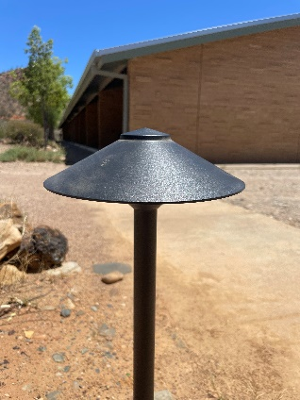
2 | New fully shielded down lights | 33 | 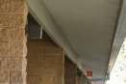
3 | Existing wall mounted lights | 17 | 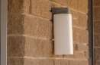
4 | Under roof mounted lights | 7 | 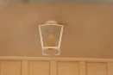
5 | Under roof mounted floodlights | 2 | 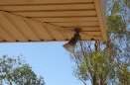
6 | Pole mounted floodlights | 9 | 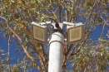
7 | Wall mounted floodlights | 2 | 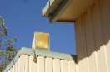

Note | Description | Qty | Photo
8 | Wall mounted fluoro lights | 1 | 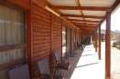
9 | Under roof mounted fluoro lights | 16 | 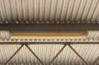
10 | Pole mounted fluoro lights | 4 | 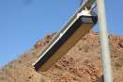

Planned Lighting Actions

ID | Description | Qty  Non conforming | Completion Date
1 | Replacing wall mounted lights with fully shielded down lights like those recently installed around the Mawson, Callitris and Greenwood verandas | 3 | December 2023
2 | Replacing wall mounted lights with fully shielded solar LED movement sensor lights | 2 | March 2024
3 | Removing lights that are not fully shielded or no longer needed | 1 | March 2024
4 | Replacing roof mounted lights with fully shielded down lights | 5 | March 2024
5 | Replacing all BBQ Area lighting with fully shielded lights with area redevelopment | 4 | March 2024

Conclusions about Lighting Inventory
The following is a summary of the lighting inventory.

Description | Qty | Percent
Lights in total currently | 154 | 100%
Lights currently non-operational, all to be replaced or removed | 3 | -
Lights currently too bright or too broad | 4 | 2.6%
Lights currently with partial or no shielding | 11 | 7.1%
Lights currently fully conforming | 139 | 90.3%
Lights that must be fully conforming before applying for IDA certification | 103 | 67%
Lights planned to be replaced | 15 | 9.7%
Lights planned to be removed | 3 | -

Night-Sky Brightness Study Details

Long-Term Night-Sky Brightness Monitoring
Arkaroola has a Unihedron Sky Quality Meter (SQM-LE) monitoring station and a Telescope Encoder and Sky Sensor (TESS-W) photometer (meter ID Stars 477) permanently located at the site of the Oliphant Observatories, which are 56 metres (184 feet) above and 435 meters (1,427 feet) from the village complex, seen in the background of the photo of the SQM meter.

SQM meter | TESS meter
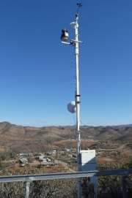 | 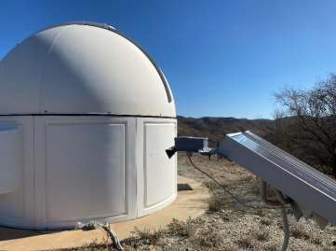

Tabular Summary of Long-Term Night-Sky Brightness Monitoring
The following includes information up to 31 January 2022.

Criteria | SQM | TESS | Note
Installation Date | 30 Sept. 2017 | 15 Dec. 2020
Nights in Operation | 1,270 | 346
Nights not in Operation | 322 | 67 | 1
Nights with at least one Reading >= 21.5 | 992 | 192
% of Nights in Operation with at least one Reading >= 21.5 | 78% | 55%
Total Readings | 2,017,146 | 1,604,440 | 2
Readings between 9pm and 4am | 529,277 | 474,270
Average % of Readings >= 21.5 per Night (9pm-4am) | 52% | 22% | 3
Notes:

Note | Description
1 | Server, network and electricity outages have occasionally occurred and lasted from minutes to weeks depending on the causes, resulting in 20% ^{(SQM)} to 16% ^{(TESS)} nights lost over 52 months (SQM) and 13 ½ months ^{(TESS)} of operation.
2 | The SQM meter takes a reading once a minute between 6:30pm and 6:30am.  The TESS meter took a reading once every 10 seconds 24 hours per day until the end of July 2021, and was then modified to only take one reading per minute, but still 24 hours per day.

Graphical Summary of Long-Term Night-Sky Brightness Monitoring
The following graphs include SQM information up to 31 January 2022.
The trendlines in both graphs show a decrease mid-year in the percent of minutes and the percent of nights reaching 21.5, which corresponds to when the Milky Way is high in the sky.
      - Percent of Minutes per Night (9pm to 4am) with SQM Reading >= 21.5
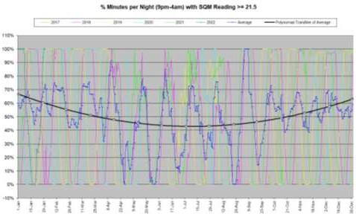
      - Percent of Nights (9pm to 4am) per Month with >= 1 SQM Reading >= 21.5
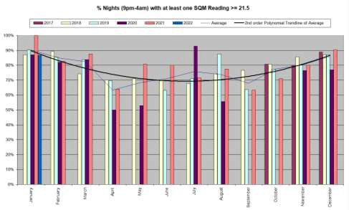

Graph of the Effect of the Moon on Night-Sky Brightness Readings
The following graph shows the percent of minutes per night (9pm to 4am) that SQM and TESS readings were >= 21.5 during 2021.
The time of moonrises and moonsets and the dates of the full moons show the effect of the Moon on readings.
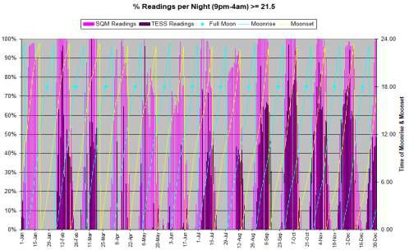

Representative Nights

SQM Readings on 8 May 2018
All readings
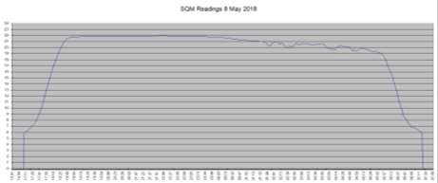
Readings >= 21.5
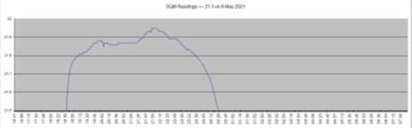
Moonrise with 53% illumination was at 00:48.

SQM and TESS Readings on 14 April 2021
All readings
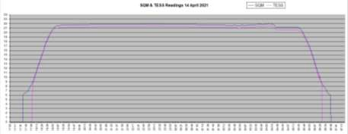
Readings >= 20.5
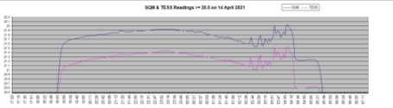

Assessment of dark sky conditions via all sky calibrated camera

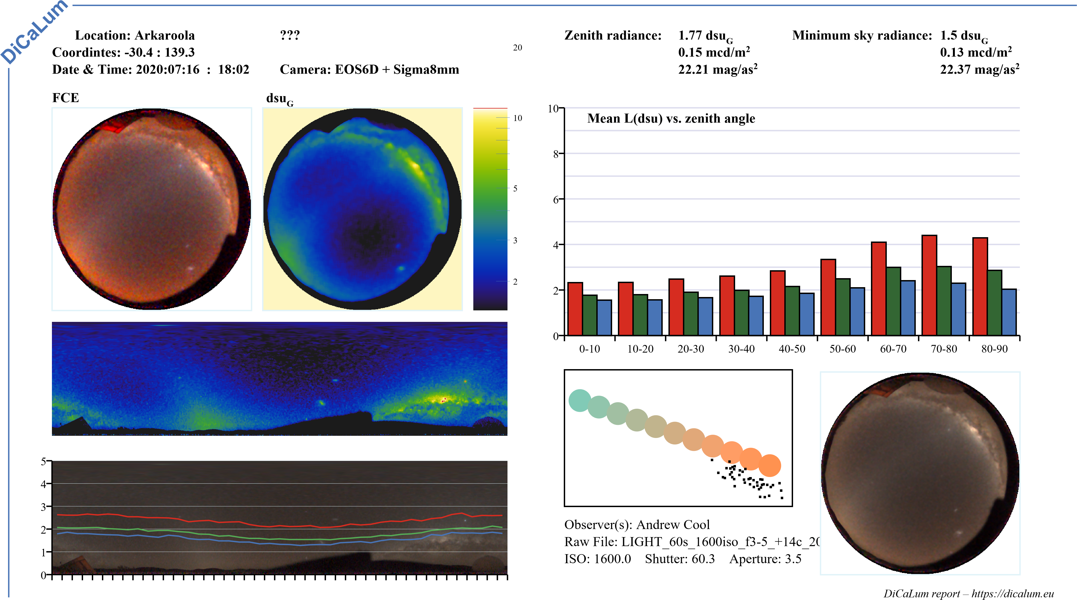

Report produced from Professor Zoltan Kollath’s Dicalum Software

Conclusions from the Long-Term Night-Sky Brightness Monitoring
- Since September 2017 Arkaroola has operated a fixed continuous monitoring sky brightness measurement program utilising a Unihedron Sky Quality Meter monitoring station, which satisfies IDA Minimum Requirement 4.
- Therefore, collected readings have been distributed over a sufficiently long enough period of time in order to average out fluctuations over timescales ranging from nights to seasons in length, which satisfies IDA Minimum Requirement 9B.
- The collected readings reveal that:
  - 52% of all readings between 9pm and 4am are greater than or equal to
21.5 magnitudes per square arc second, and
  - 78% of all nights had at least one reading greater than or equal to 21.5 magnitudes per square arc second.
- This shows that Arkaroola has an exceptional dark-sky resource where the night-sky brightness at the zenith is routinely equal to or darker than 21.5 magnitudes per square arc second in the visual band, which satisfies IDA Eligibility Criteria 4.
- For about a week around each full moon, all readings are reduced below 21.5.
- The Milky Way season mid-year reduces by about 30% the number of readings >= 21.5 per night.

Location Photos
The following sub-sections provide some idea of the quality of the night sky from locations within the Arkaroola Village.

Ningana Imaging Observatory
Taken at 11:41pm ACDT on 3 April 2019 under the 3% illuminated disk of the Moon, capturing the Ningana Observatory in front of Griselda Hill, the southern Milky Way and both Magellanic Cloud galaxies. Notice that the hill is darker than the sky and shows no sign of light pollution from the village. Canon 750d, 11mm, f/2.8, 30s, ISO-3200.
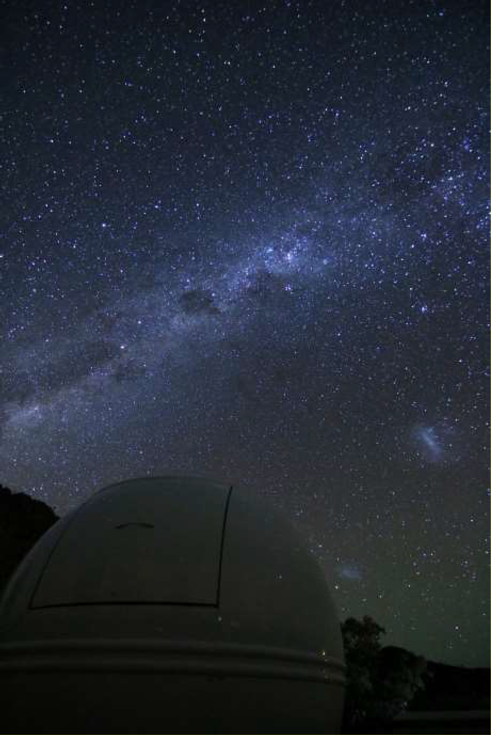

Arkaroola Swimming Pool
Taken at 3:42am ACDT on 20 December 2019 under the 44% illuminated disk of the Moon at 22° elevation. Notice that Canis Major and Orion are clearly visible. Canon 750d, 11mm, f/3.2, 30s, ISO-1600.
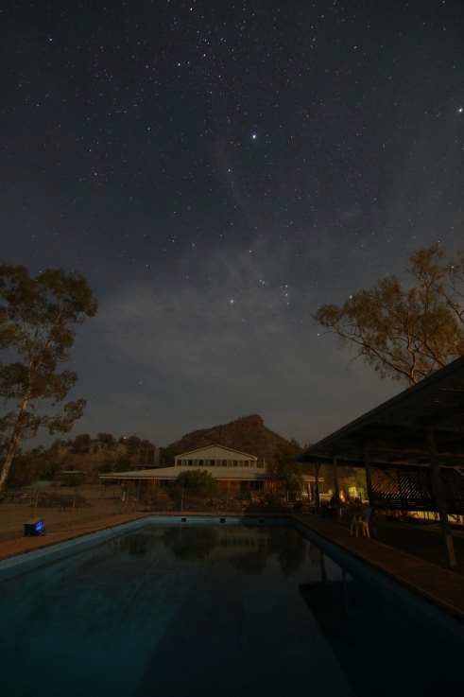

Helicopter Landing Pad
Taken at 3:59am ACDT on 6 December 2020 under the 74% illuminated disk of the Moon at 34° elevation, capturing the re-entry of Japan’s Hayabusa2 spacecraft over the Woomera Prohibited Area, which is more than 260 kms west of Arkaroola. Notice that Orion, Taurus and the Pleiades are visible. Canon 750d, 11mm, f/2.8, 10s, ISO-1600.
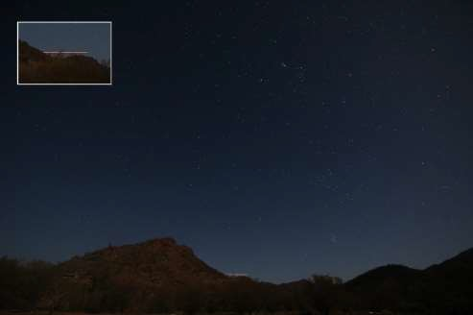

Future Night-Sky Brightness Studies
Arkaroola will continue to use its permanent fixed Unihedron Sky Quality Meter continuous monitoring station at the Oliphant Observatory, as well as conduct spot data collection around the property at least annually to quantify sky darkness for inclusion in its annual report to IDA.

End Of Document

